***Attention students:***

***In order to demonstrate successful completion of all components in the project, please use screenshot(s) to show each completed action step as specified on the instructions page.***

**Identity and Access Management**

1. Proof of Assigned roles and AD assignments
   1. Andrew
   2. Chris
   3. Karl
   4. Lora
   5. Neelima
   6. Neha
   7. Seth
   8. Srinadh
   9. Tom
   10. Winifred

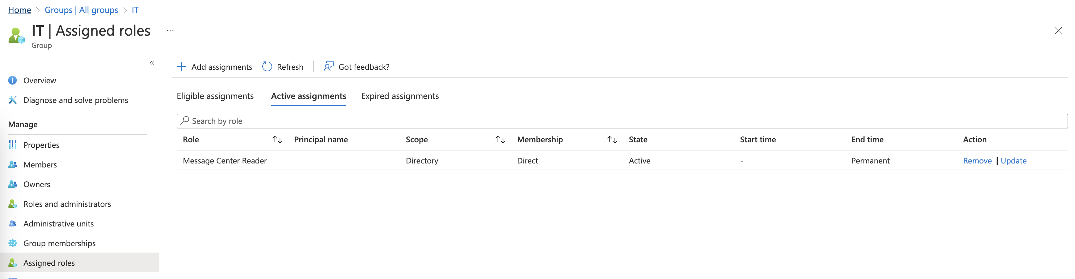

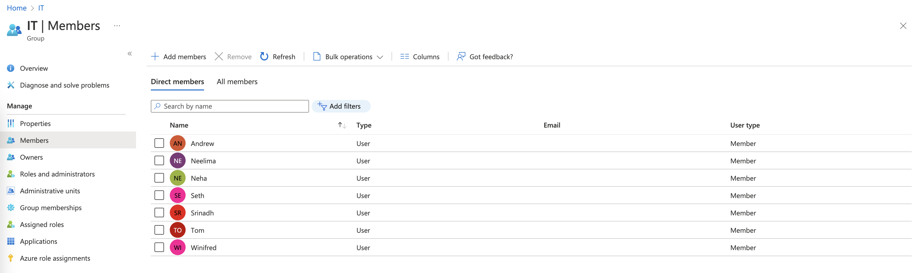

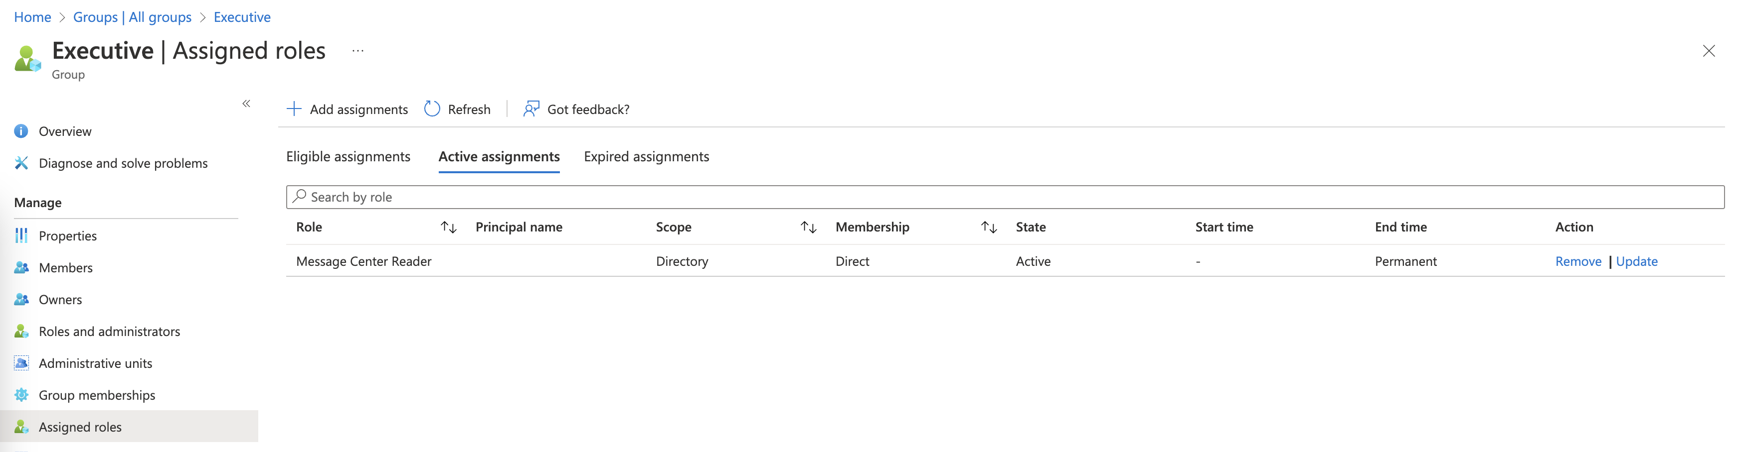

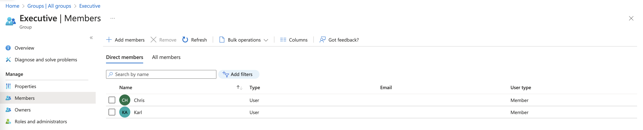

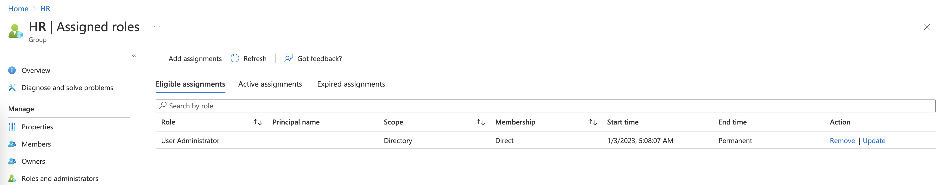

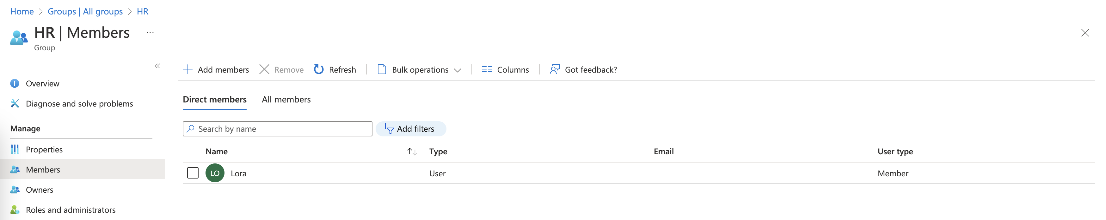

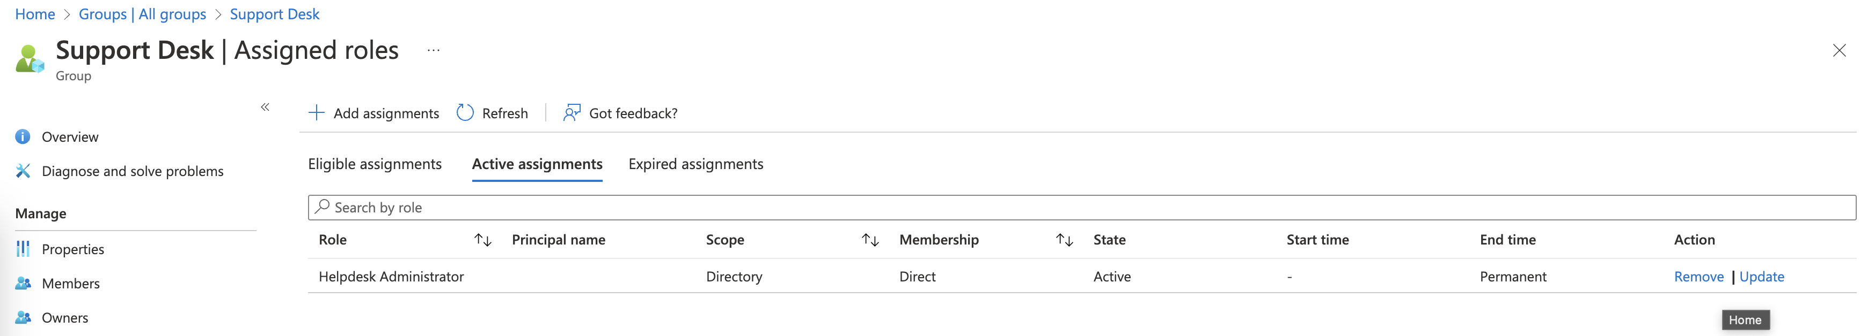

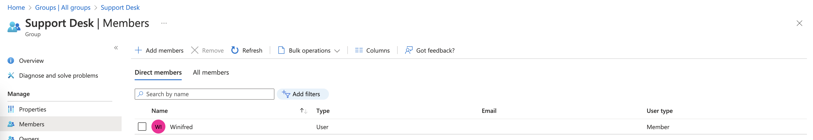

The COO will have the Billing Admin role active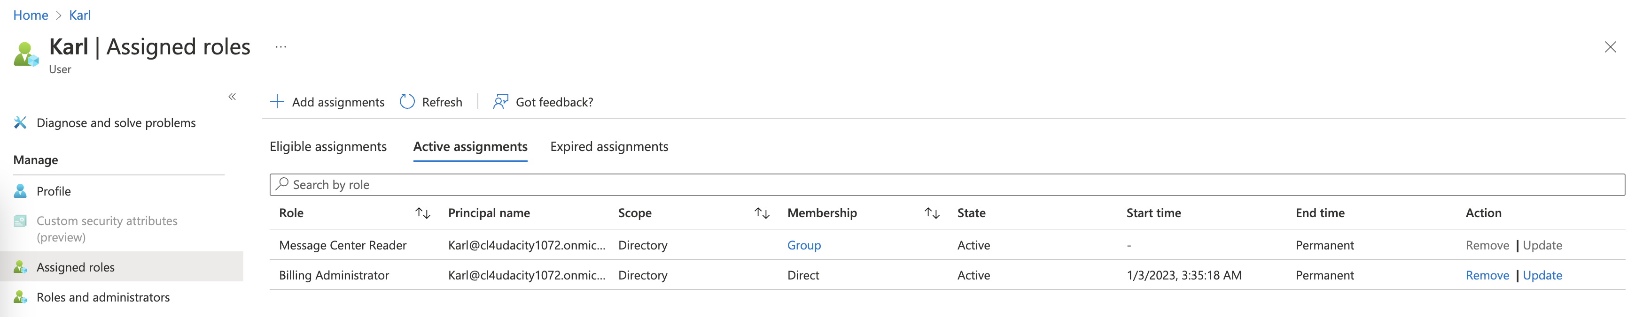

The Azure Architect will be eligible for the Global Admin and Billing admin roles

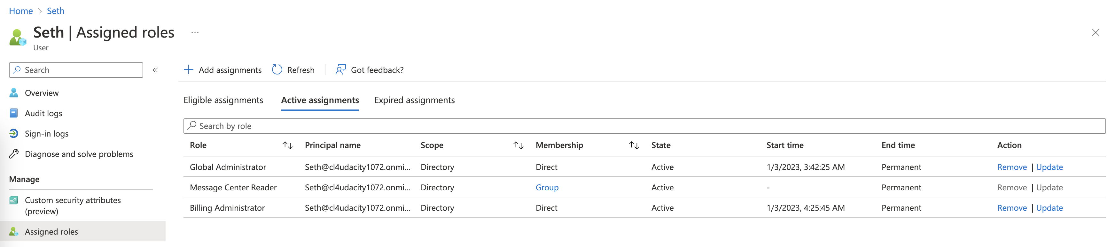

The CIO will not continually work in the environment however, they will need the same Azure AD access should the need arise to step in for the Azure Architect

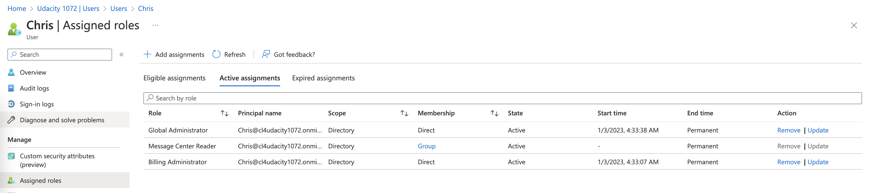

Development DBA will only need to access the Dev Database

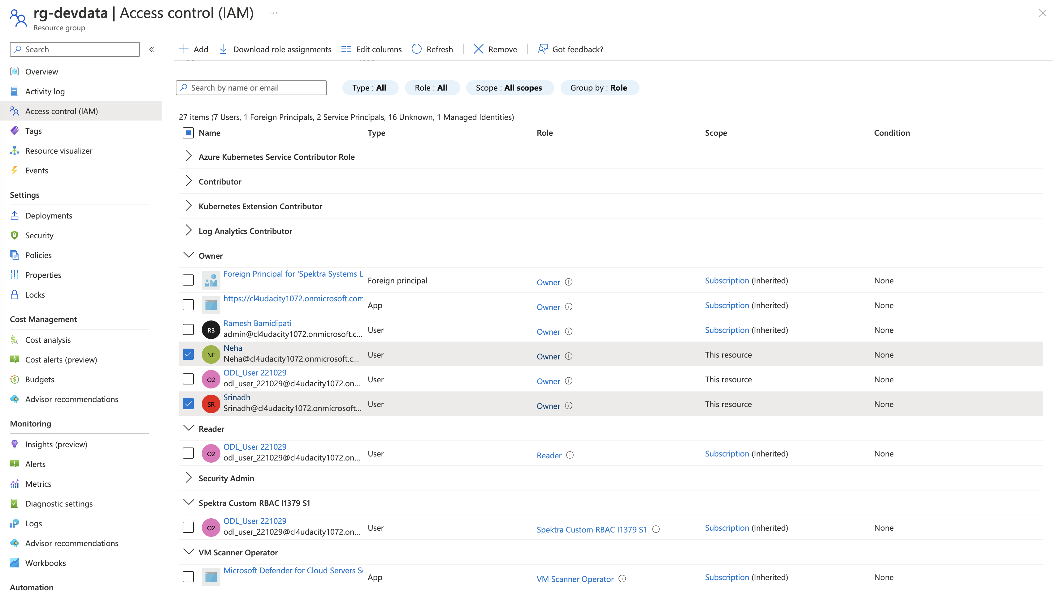

The lead DBA will need access to all SQL infrastructure and data

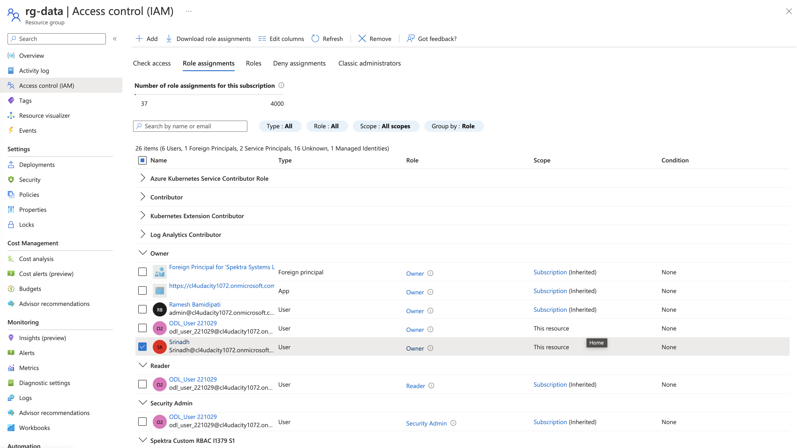

The IT Engineers will each need access to their assigned environments but will not need to provide this access to others

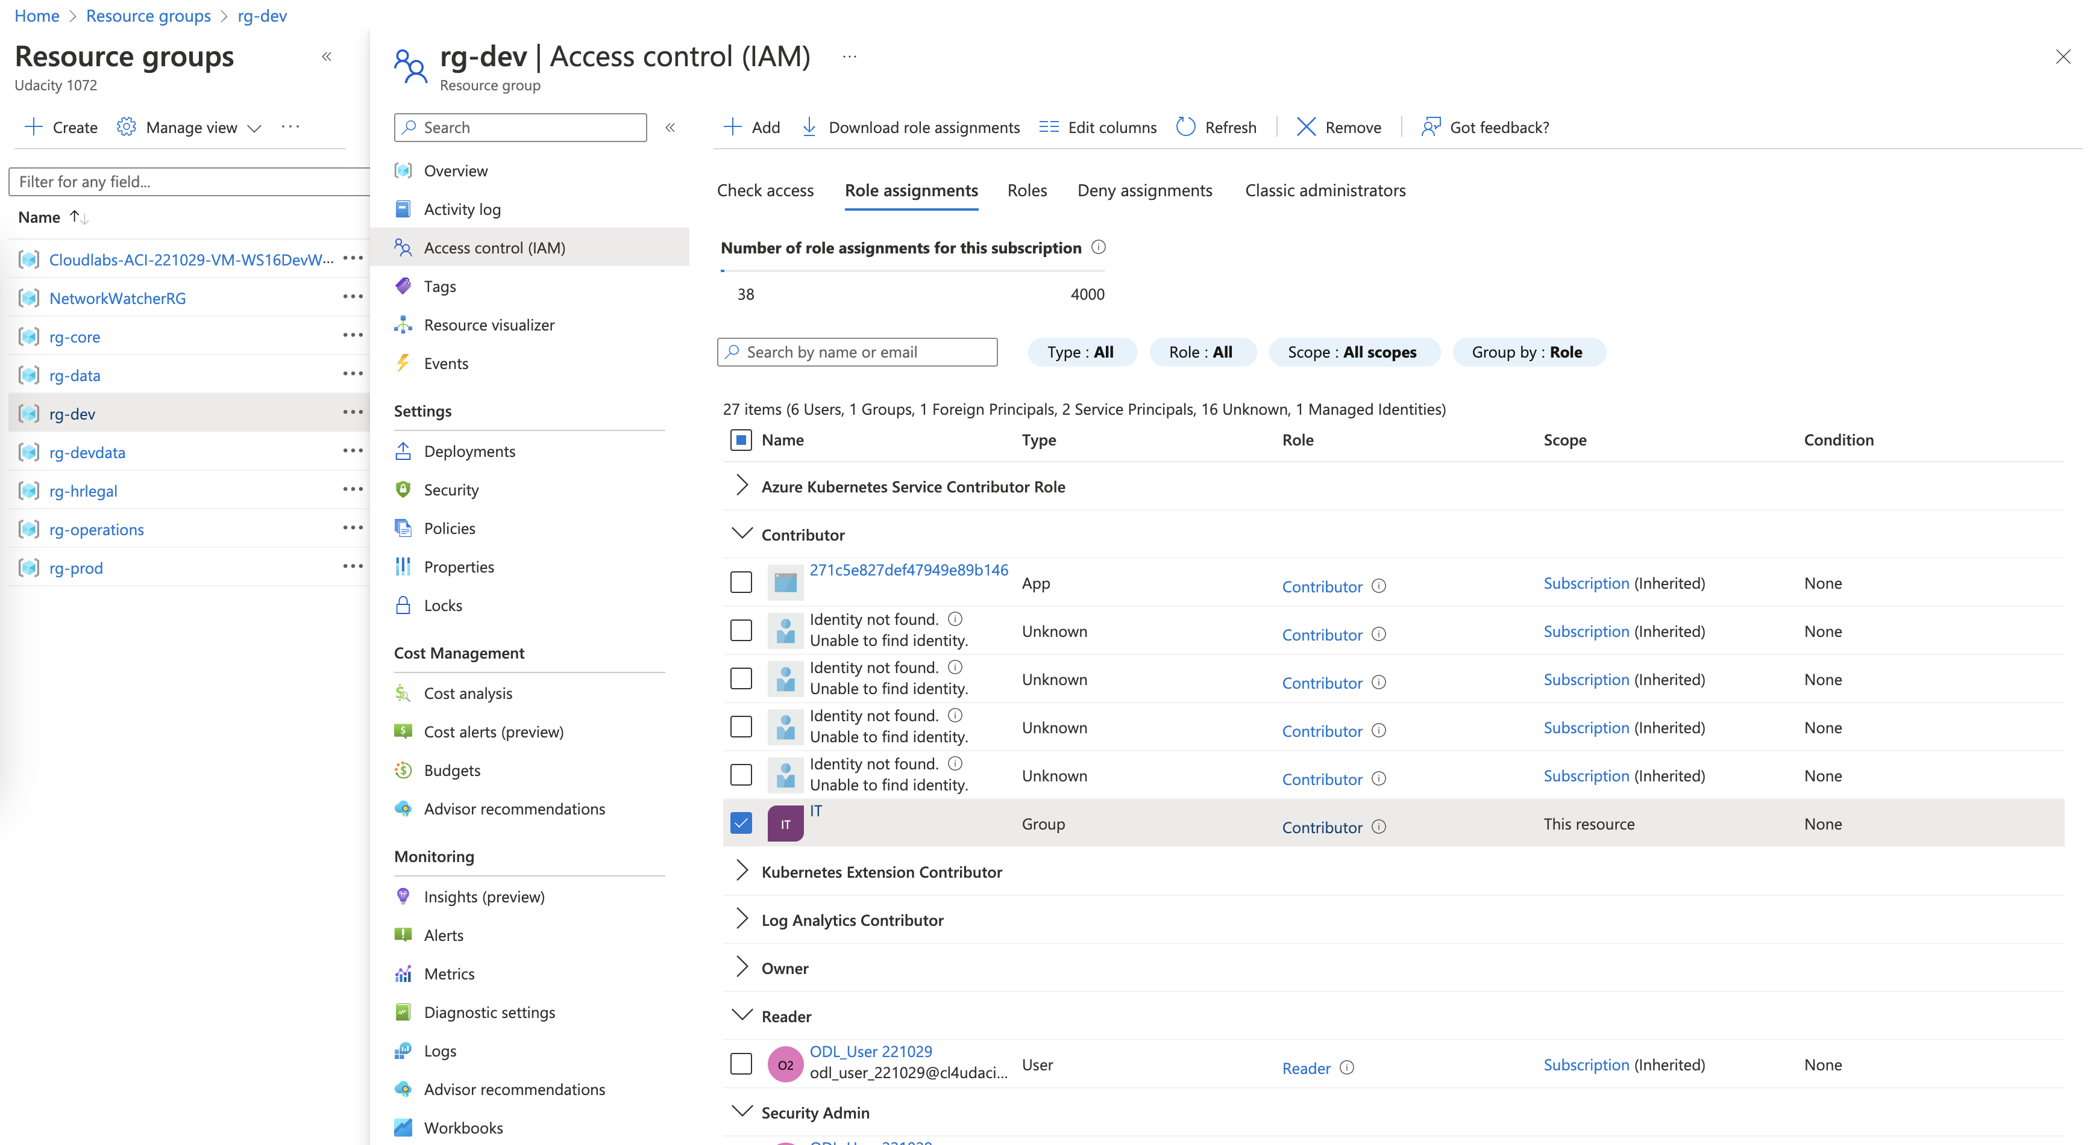

Development Lead will each need access to their assigned environments but will not need to provide this access to others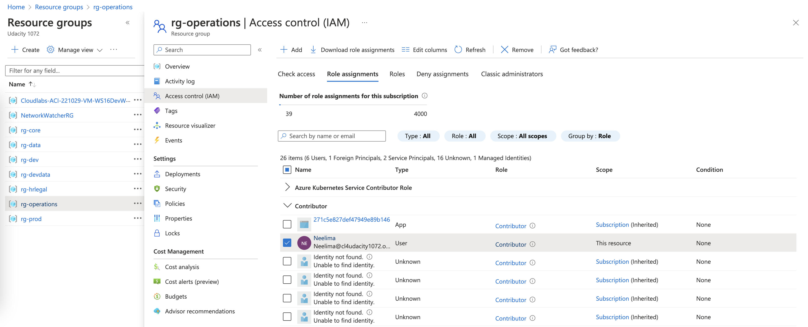

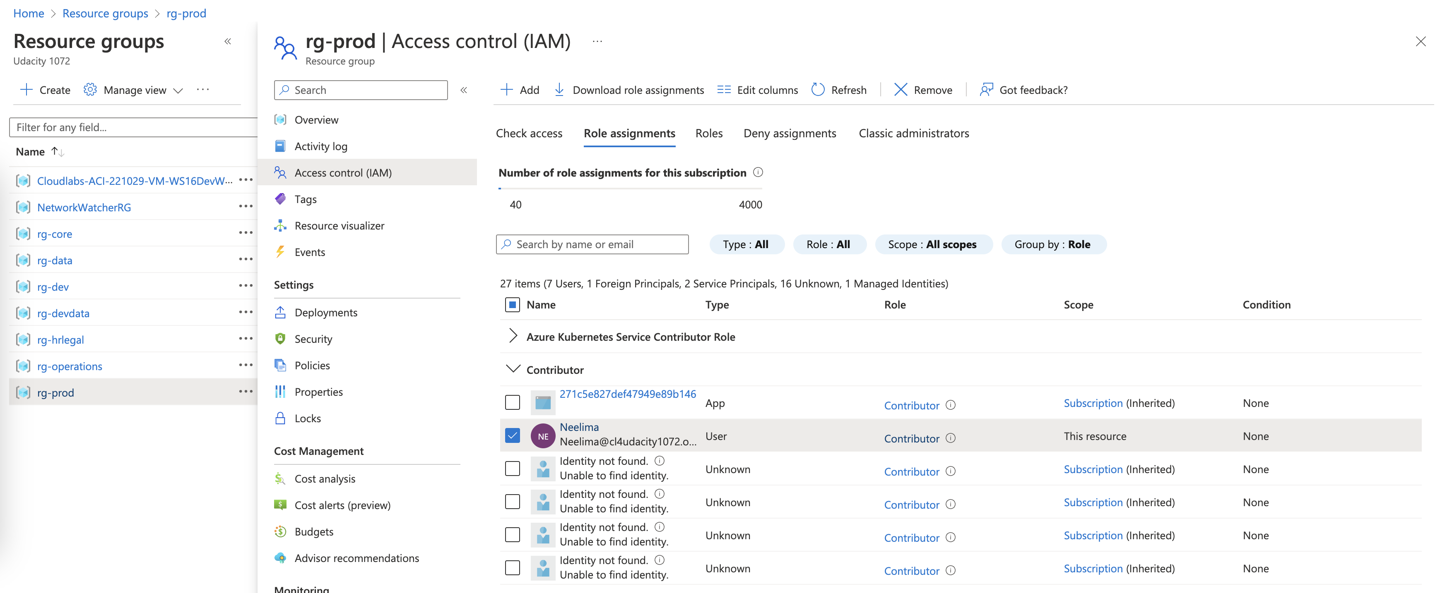

1. Proof of Global Administrator setting with duration, eligibility, expiration

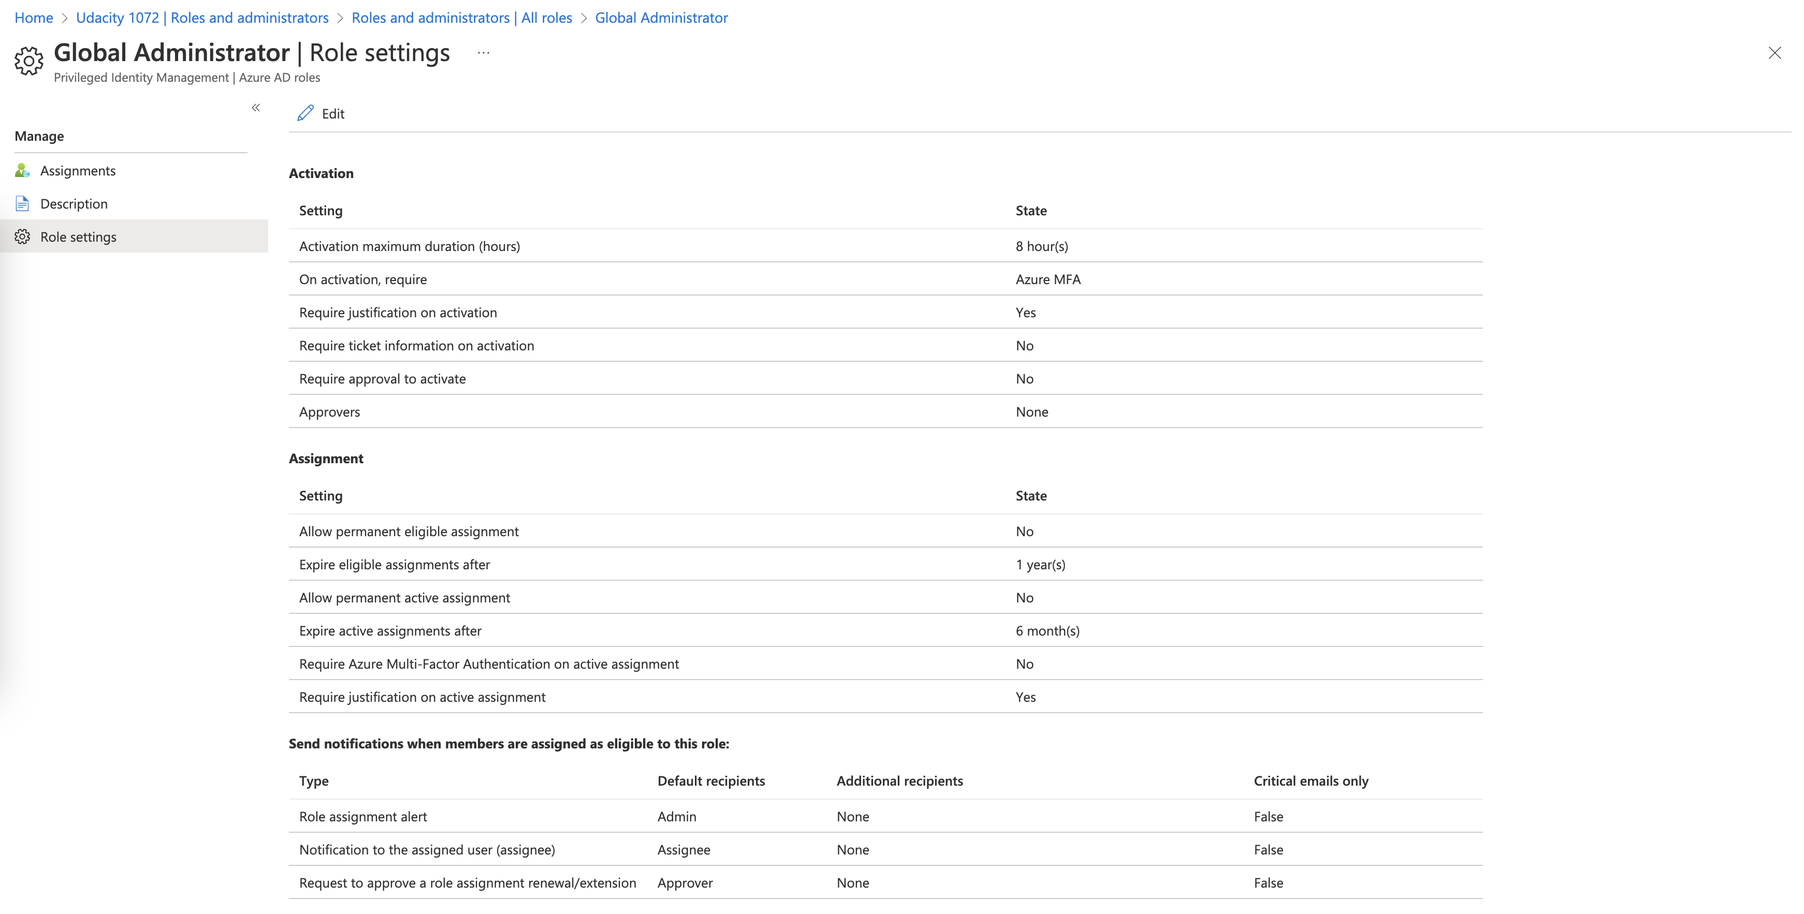

1. Proof of Conditional Access policy all users

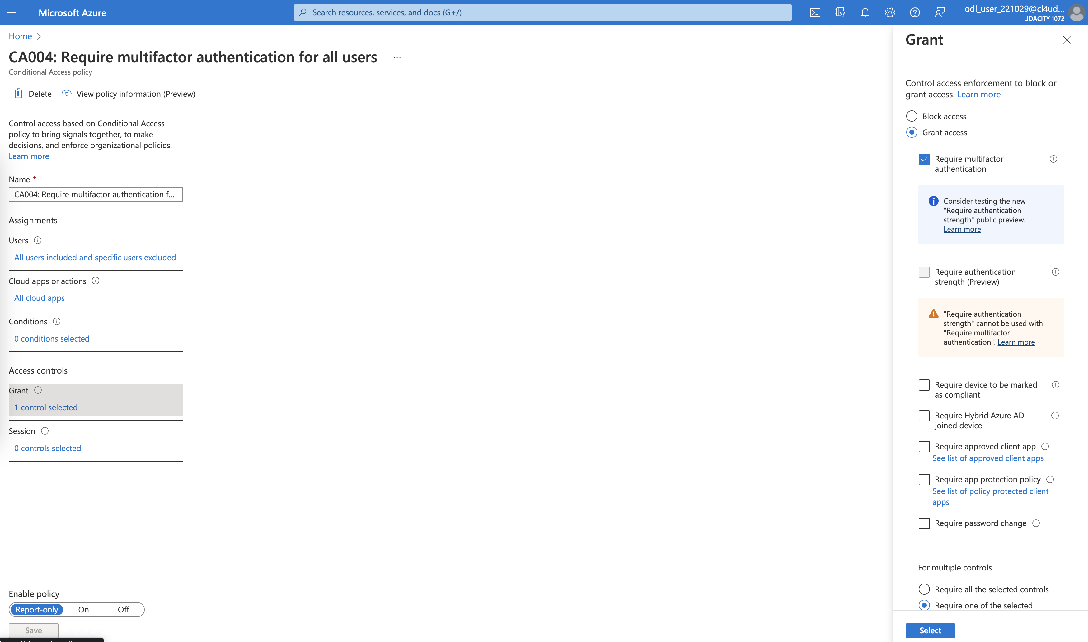

1. Proof of Multi-factor authentication(14 days, Charlotte office info)

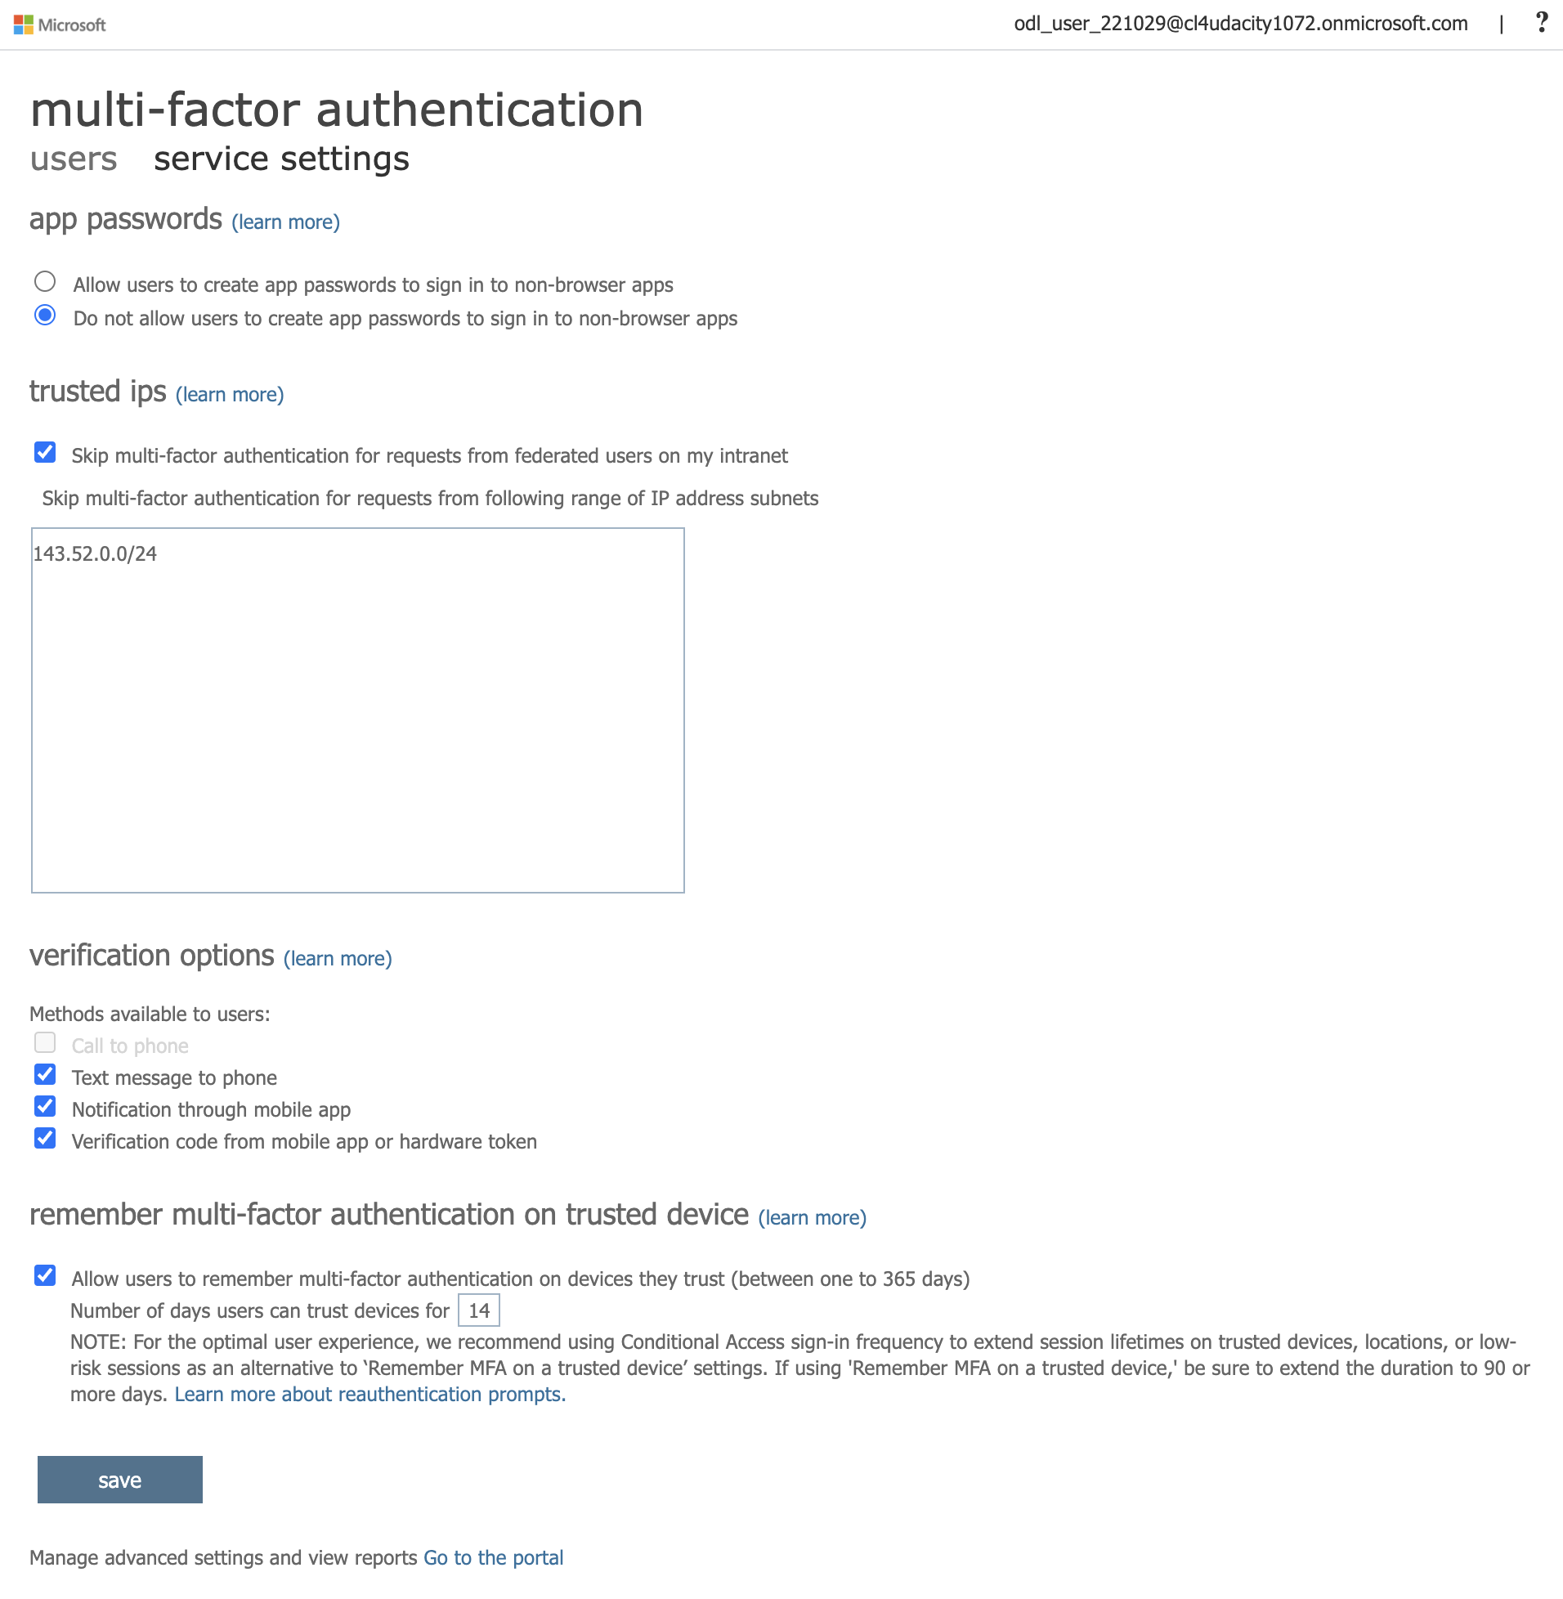

**Network Security**

1. Bastion overview

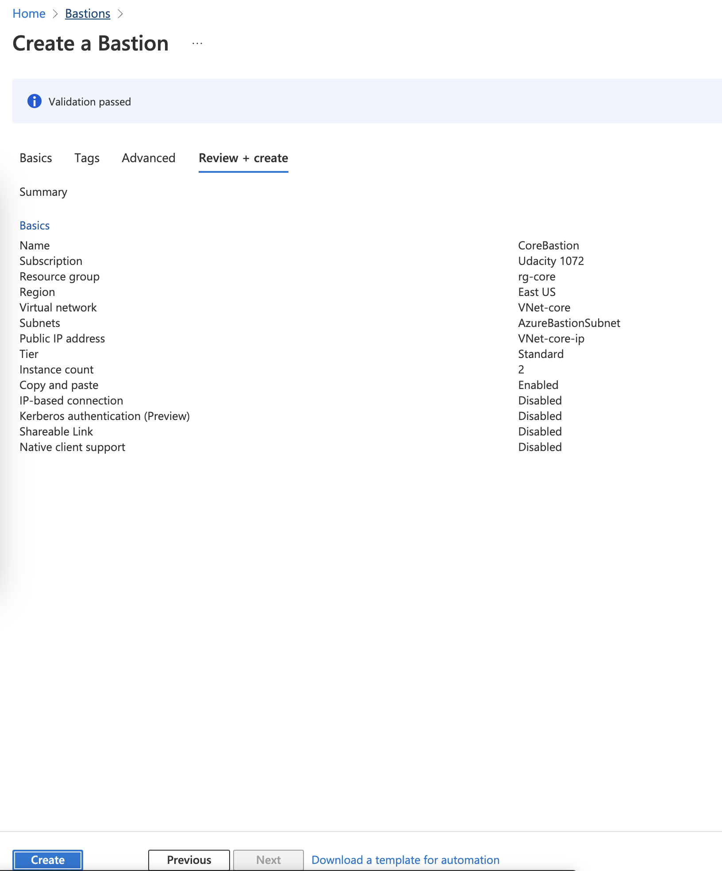

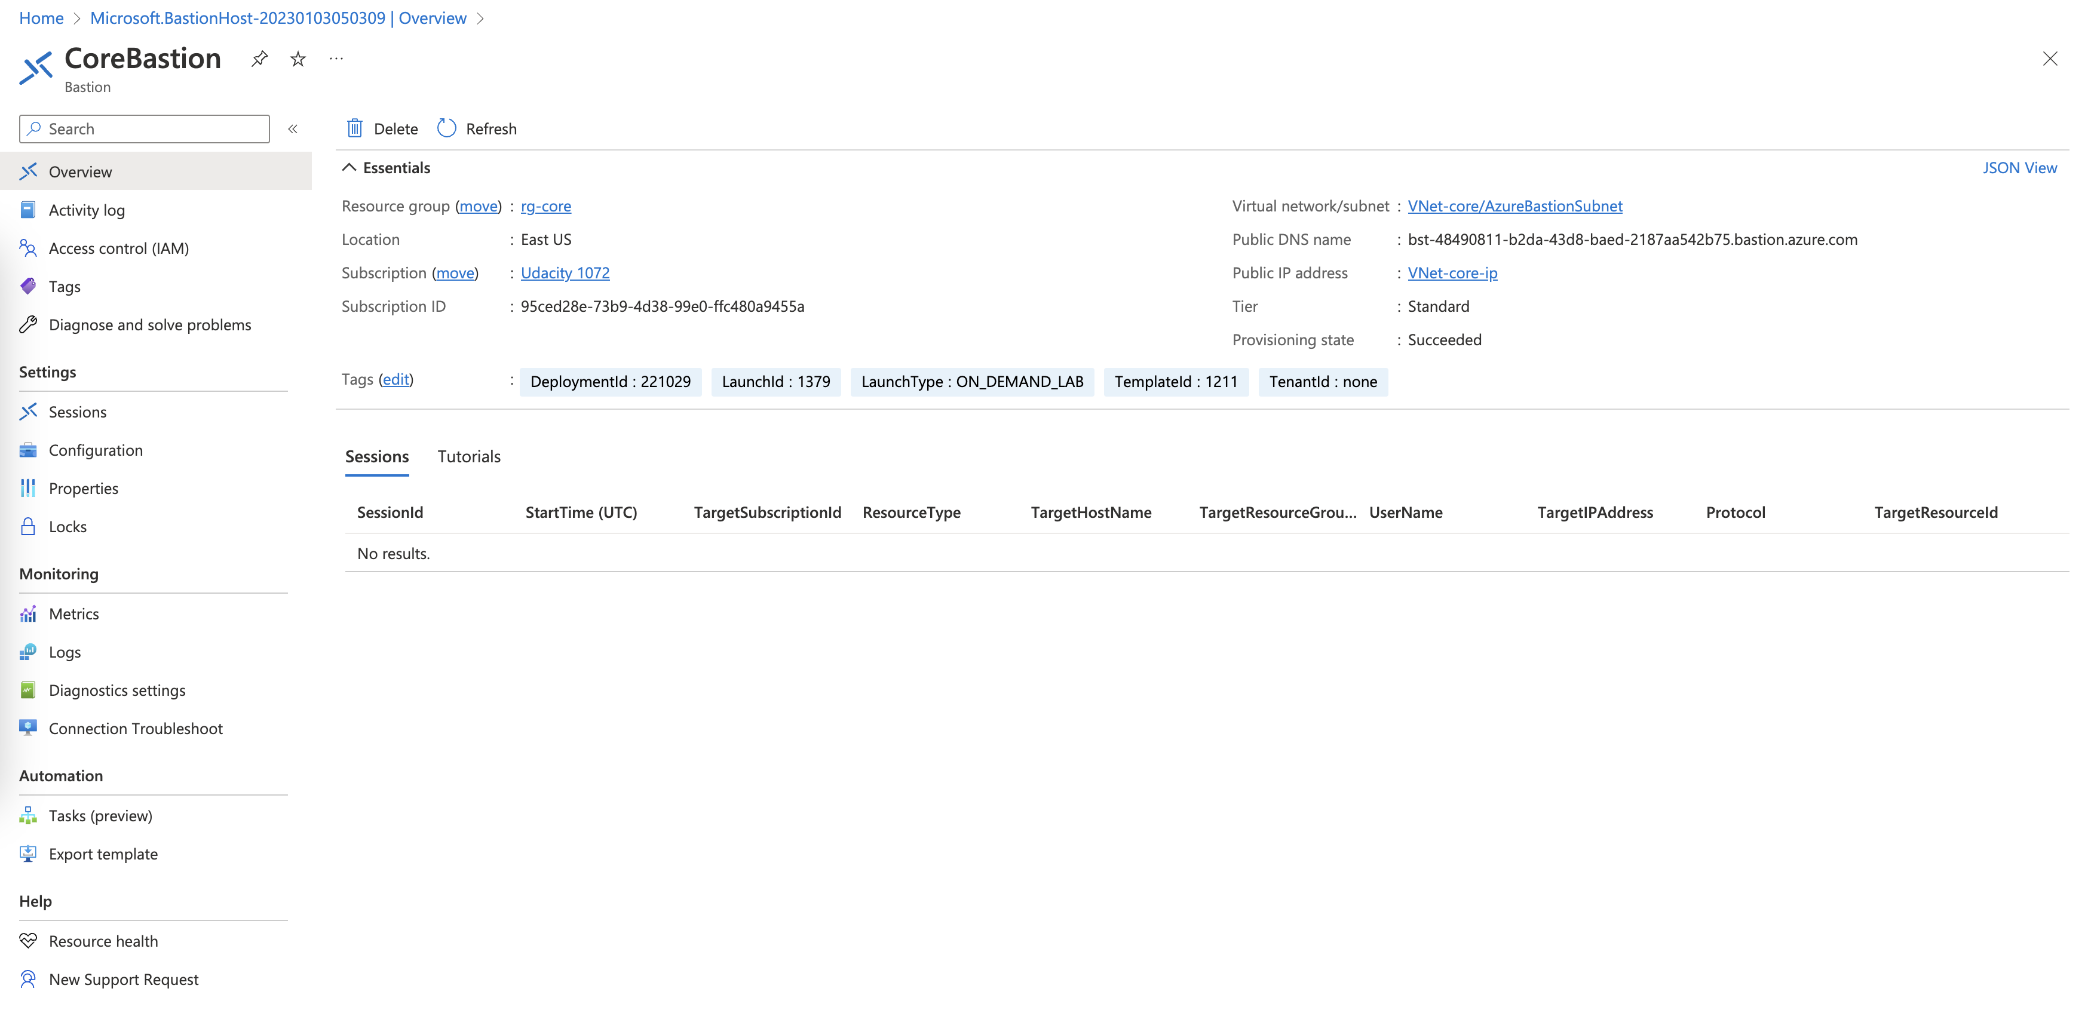

1. Proof of public IP addresses removed

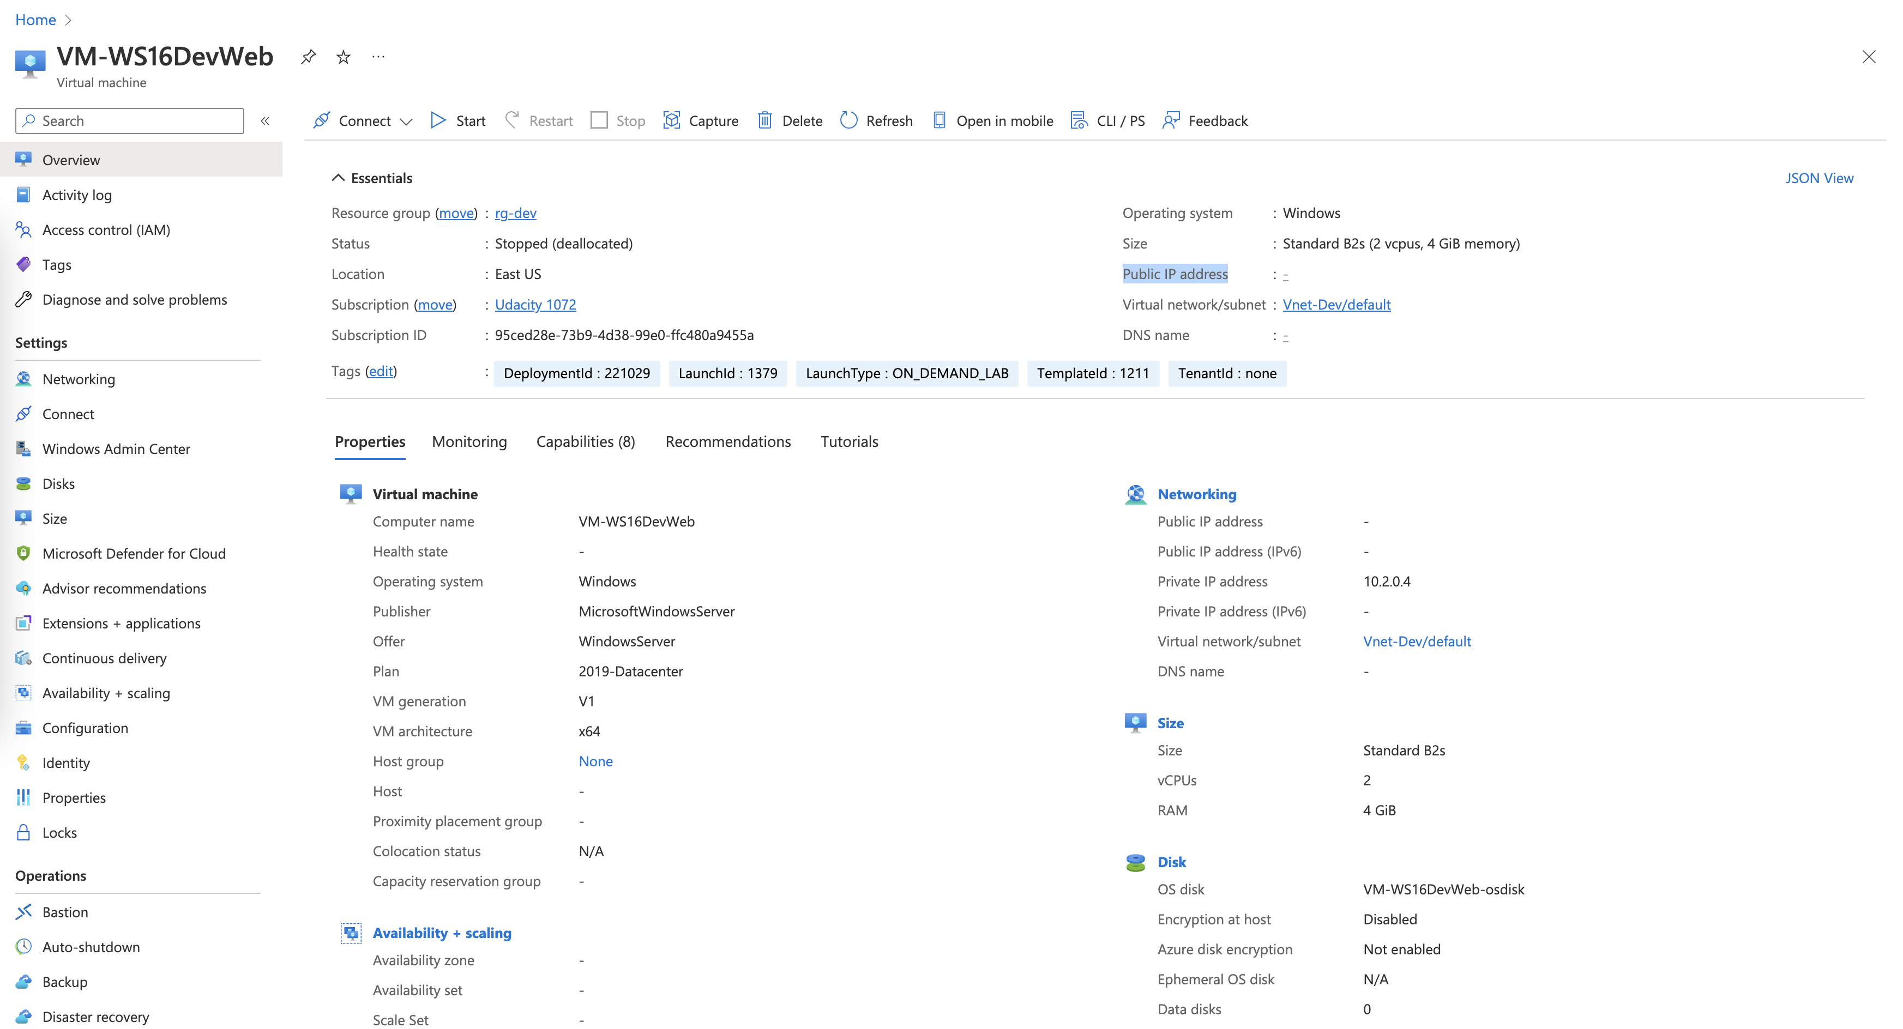

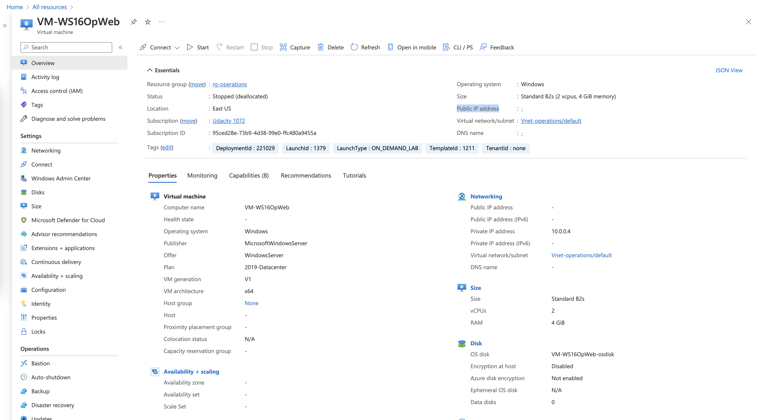

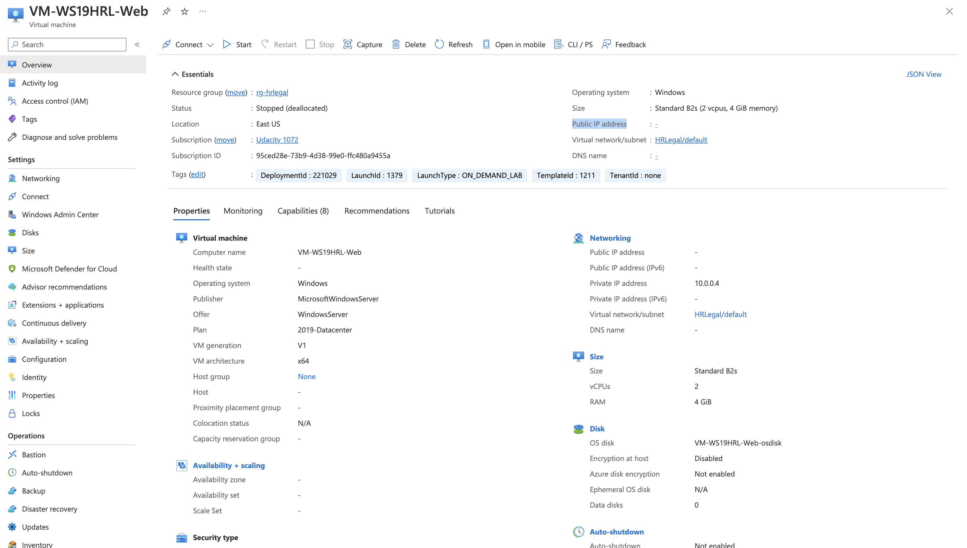

**Data and Encryption**

1. Proof of Encryption types for VM ( devapp,OpWeb,HRL-App,OPApp, HRL-Web)

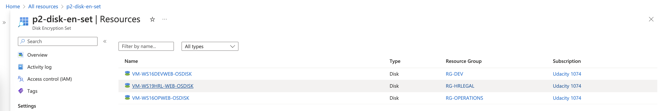

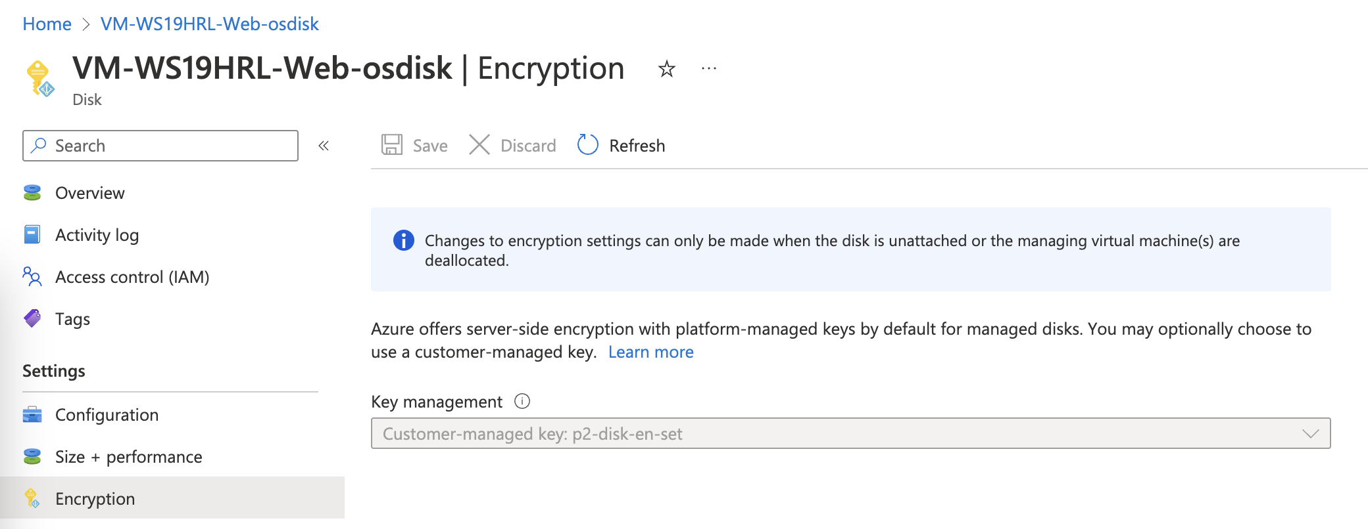

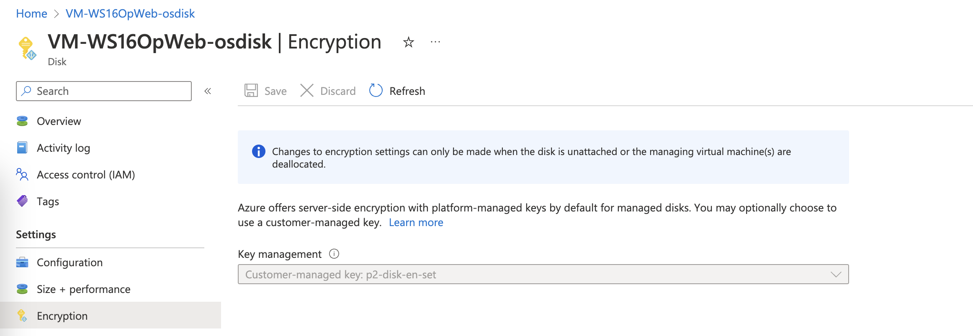

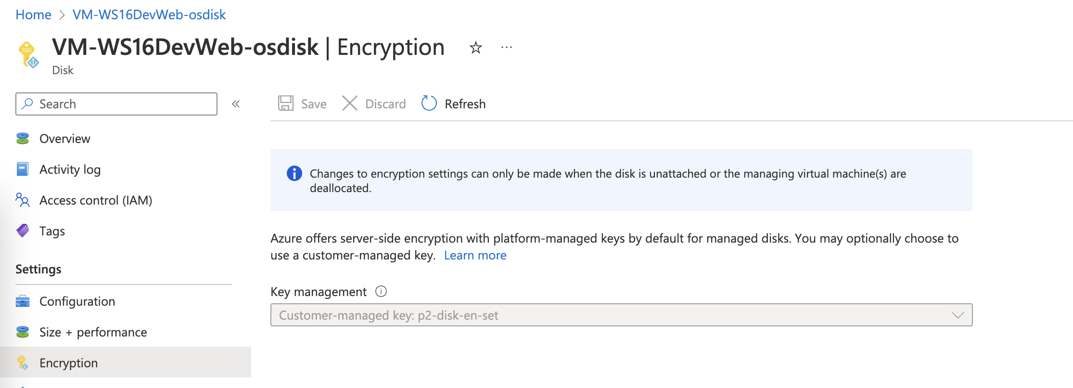

1. Firewalls and virtual networks page
   1. Proof of no public access and TLS for SQL servers(prod, dev)

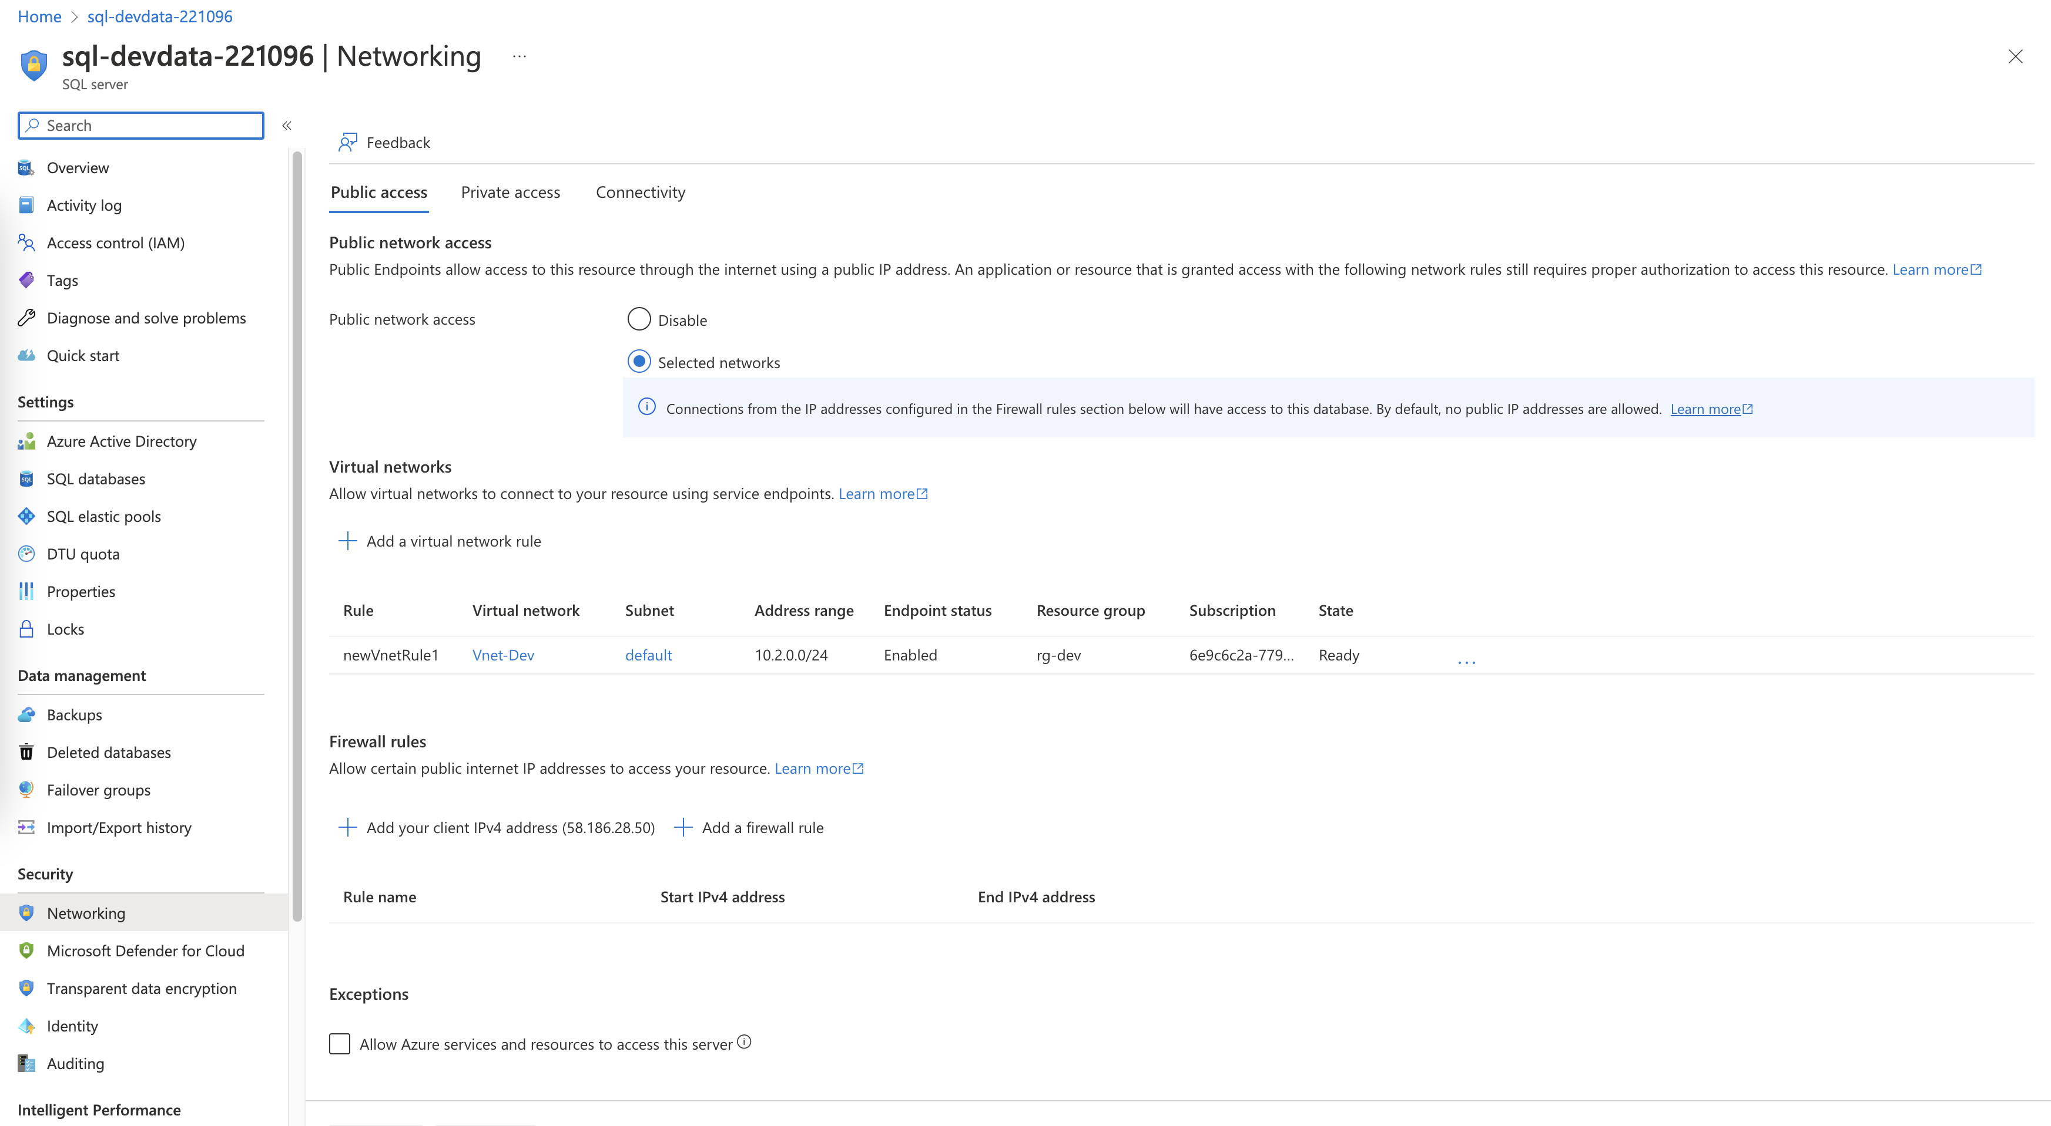

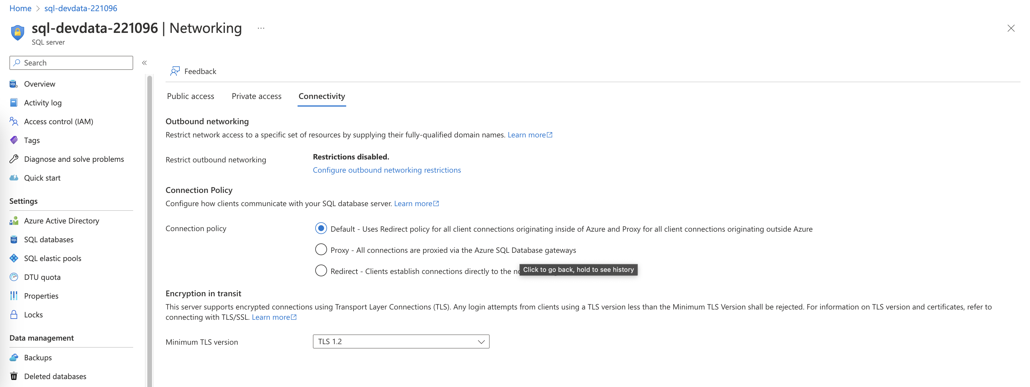

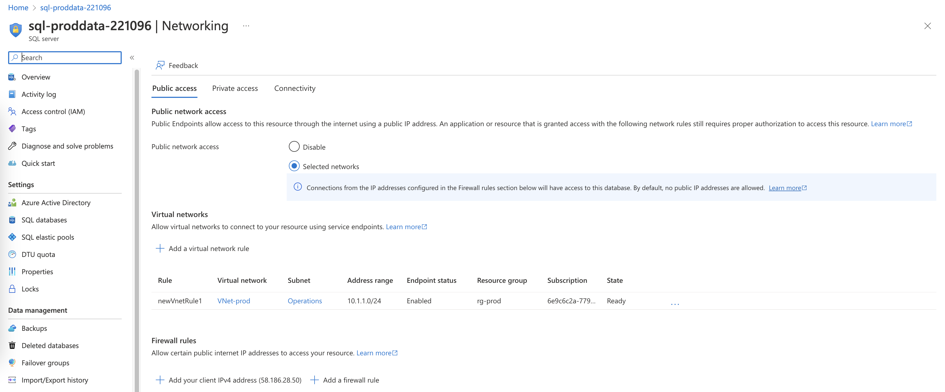

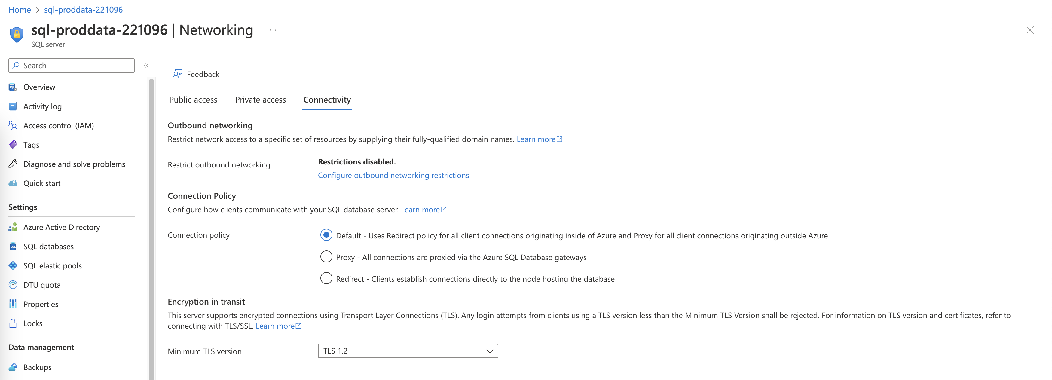

1. Proof of Azure Defender SQL server enabled(prod, dev)

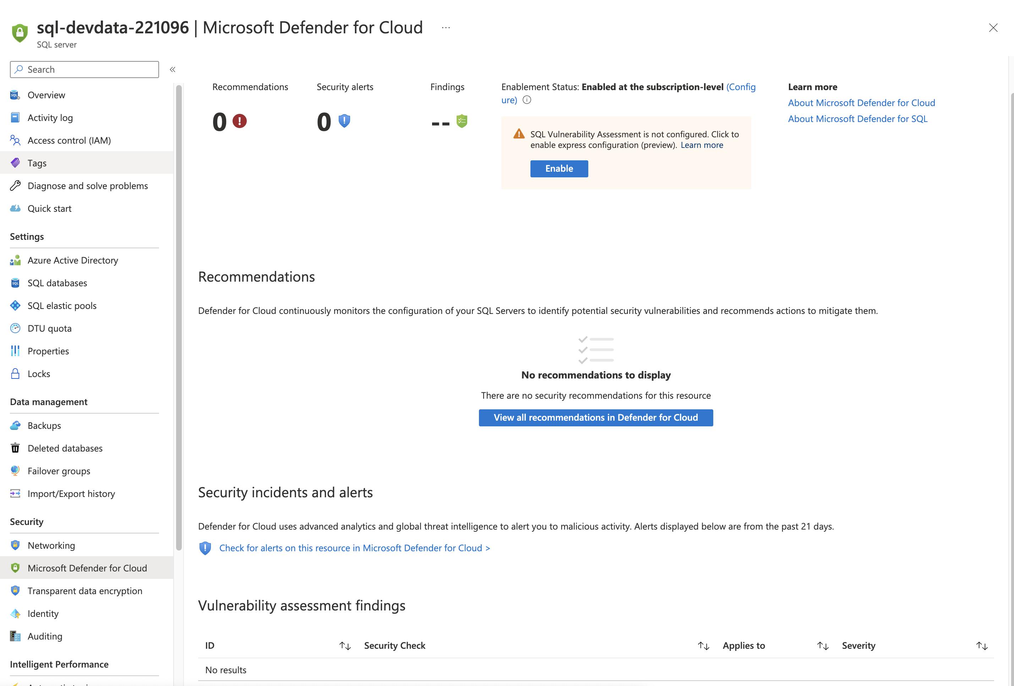

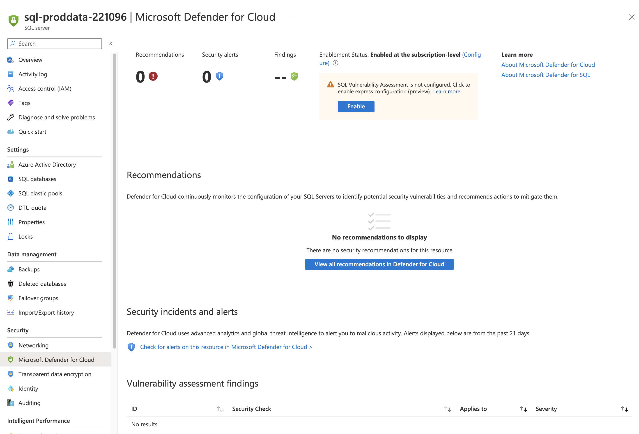

1. Proof of Azure AD authentication for SQL enabled(prod, dev)

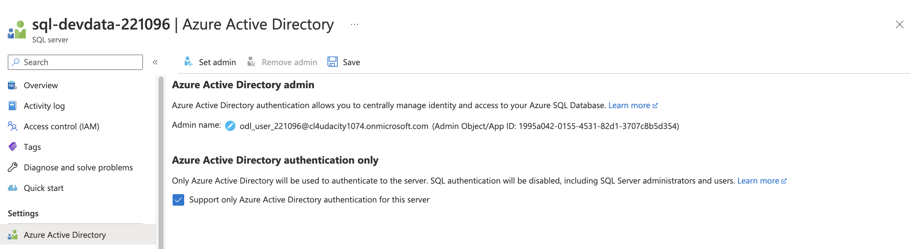

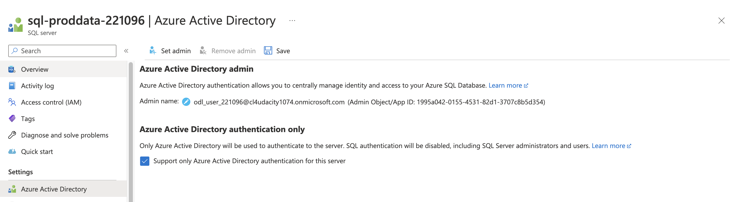

**Cloud Protection**

1. Proof of IaaSAntimalware enabled ( devapp,OpApp,HRL-Web, HRL-App,OpWeb)

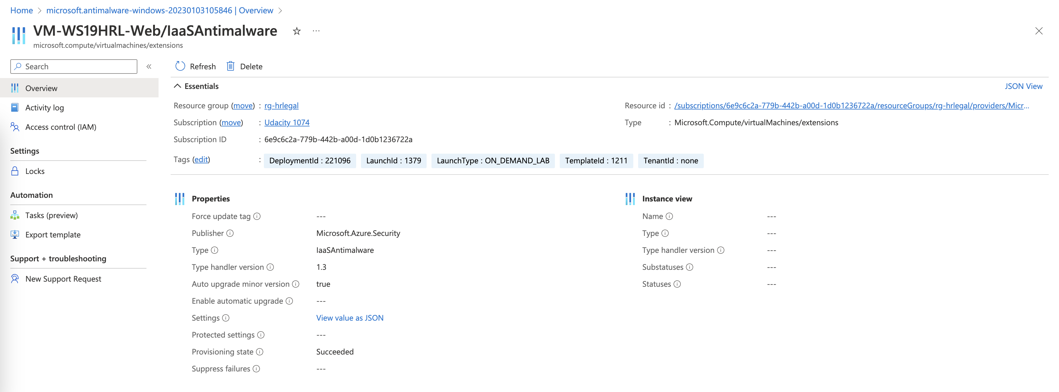

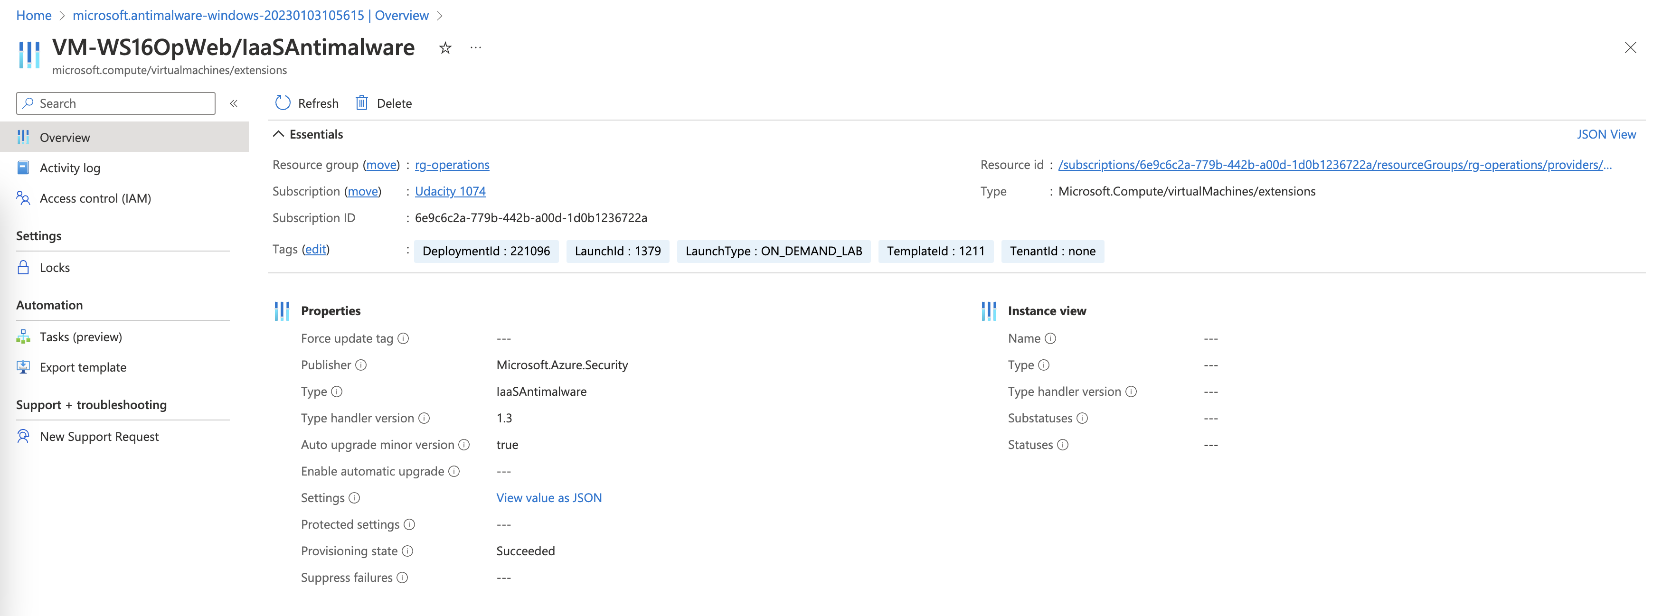

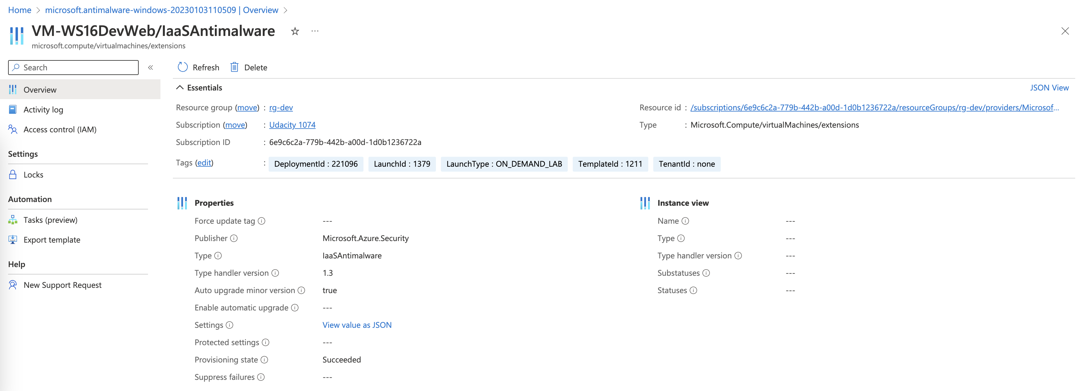

1. Recommendations

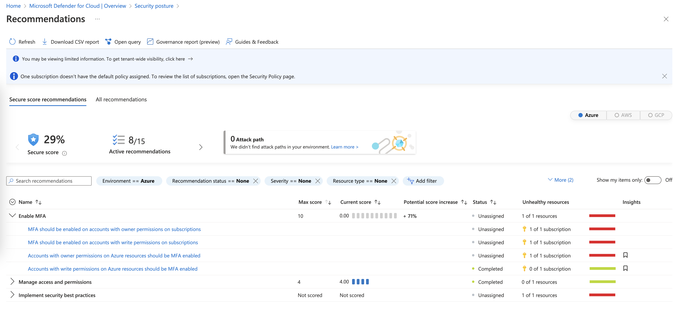

1. Based on the security score, the “Enable MFA” has the greatest impact on security (0/10 score).
2. MFA should be enabled on accounts with owner permissions on subscriptions
3. MFA should be enabled on accounts with write permissions on
4. Accounts with owner permissions on Azure resources should be MFA enabled
5. Accounts with write permissions on Azure resources should be MFA enabled

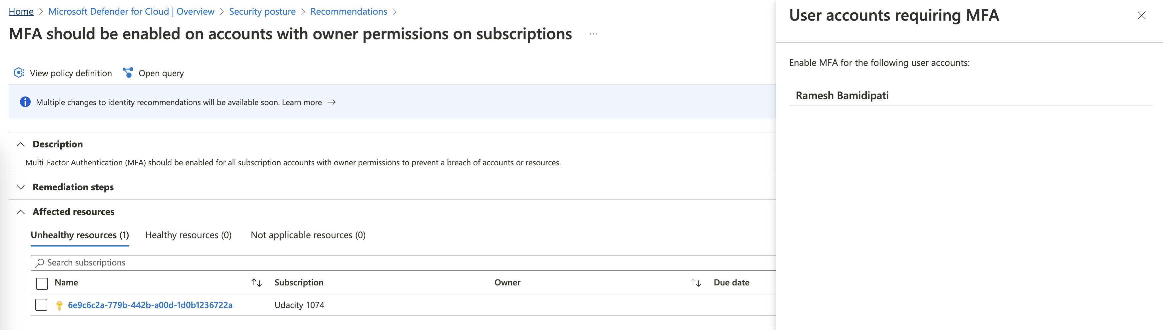

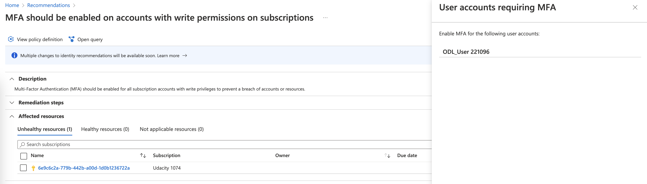

The MFA is disabled for the account Ramesh Bamidipati which has owner permissions and ODL_User 221096 which has write permissions.

* We should apply a Policy to enforce using MFA for all users (including owner, write role)

1. The “Manage access and permissions” is already solved (4/4 score)
2. Implement security best practices

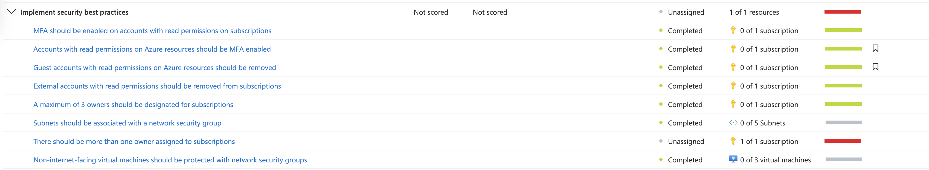

There is 1 unresolve point in the best practices: 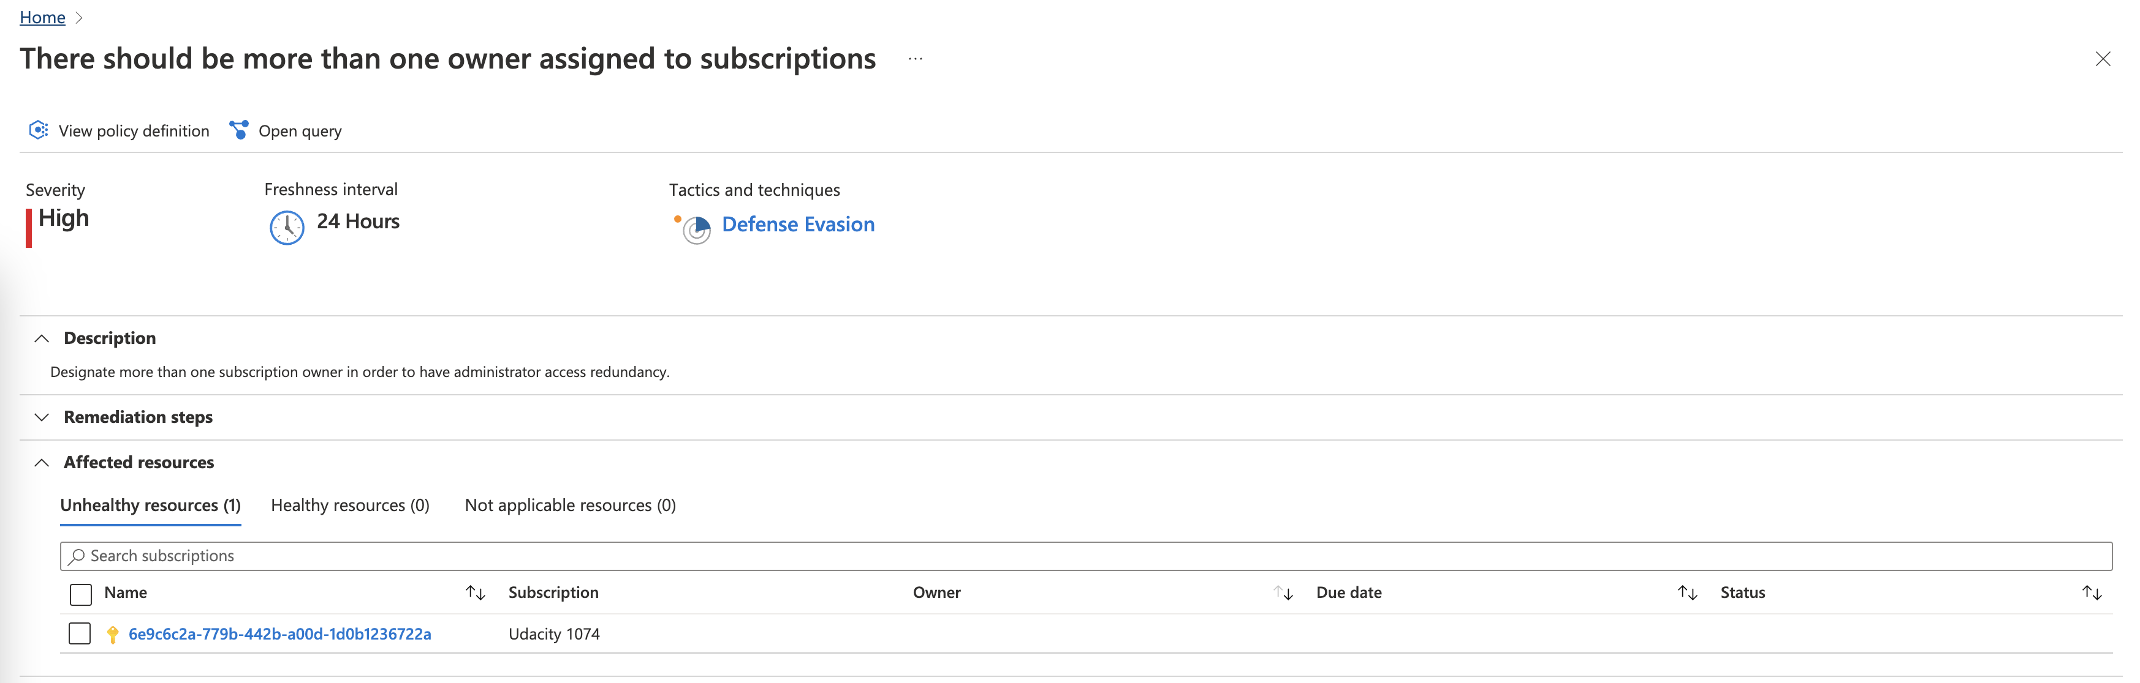

This point recommends having at least 2 users with owner role in a subscription. Designate more than one subscription owner in order to have administrator access redundancy so that if one of the owners forget or lost their password, or the account is hacked, etc. we still have at least 1 other owner.

To add assign an user as an owner, we can use the Access Control (IAM)

**Monitoring**

*Identify 3 items from the Audit log and explain what each log shows.*

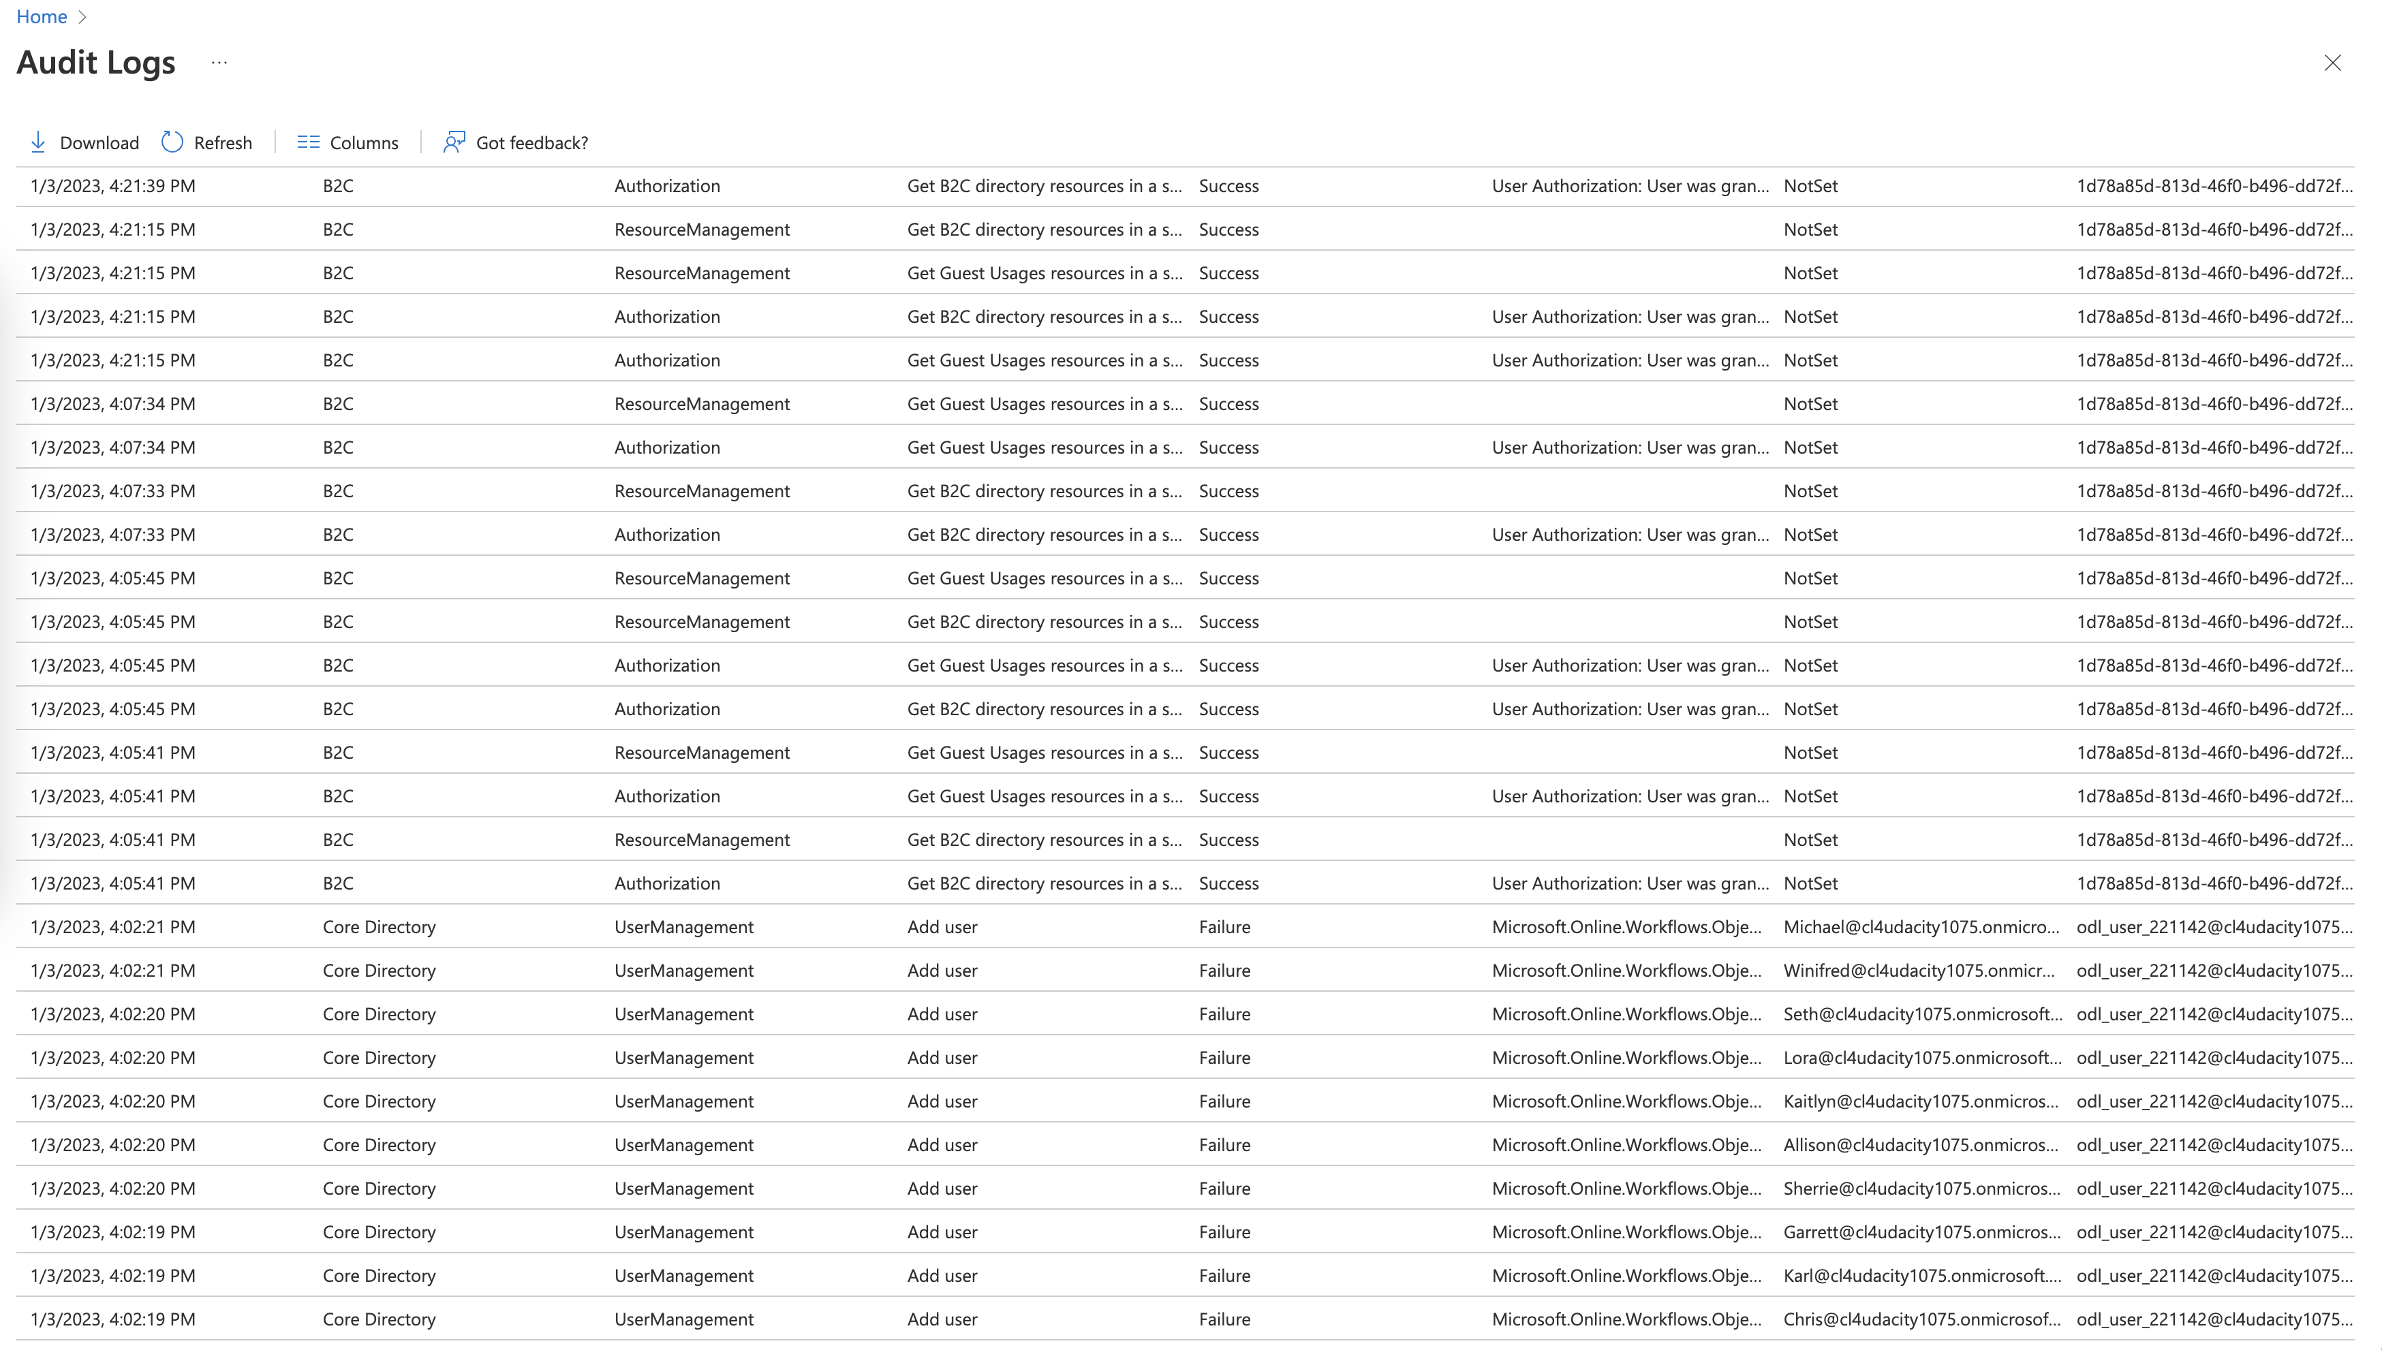

* Audit Log 1: Add User 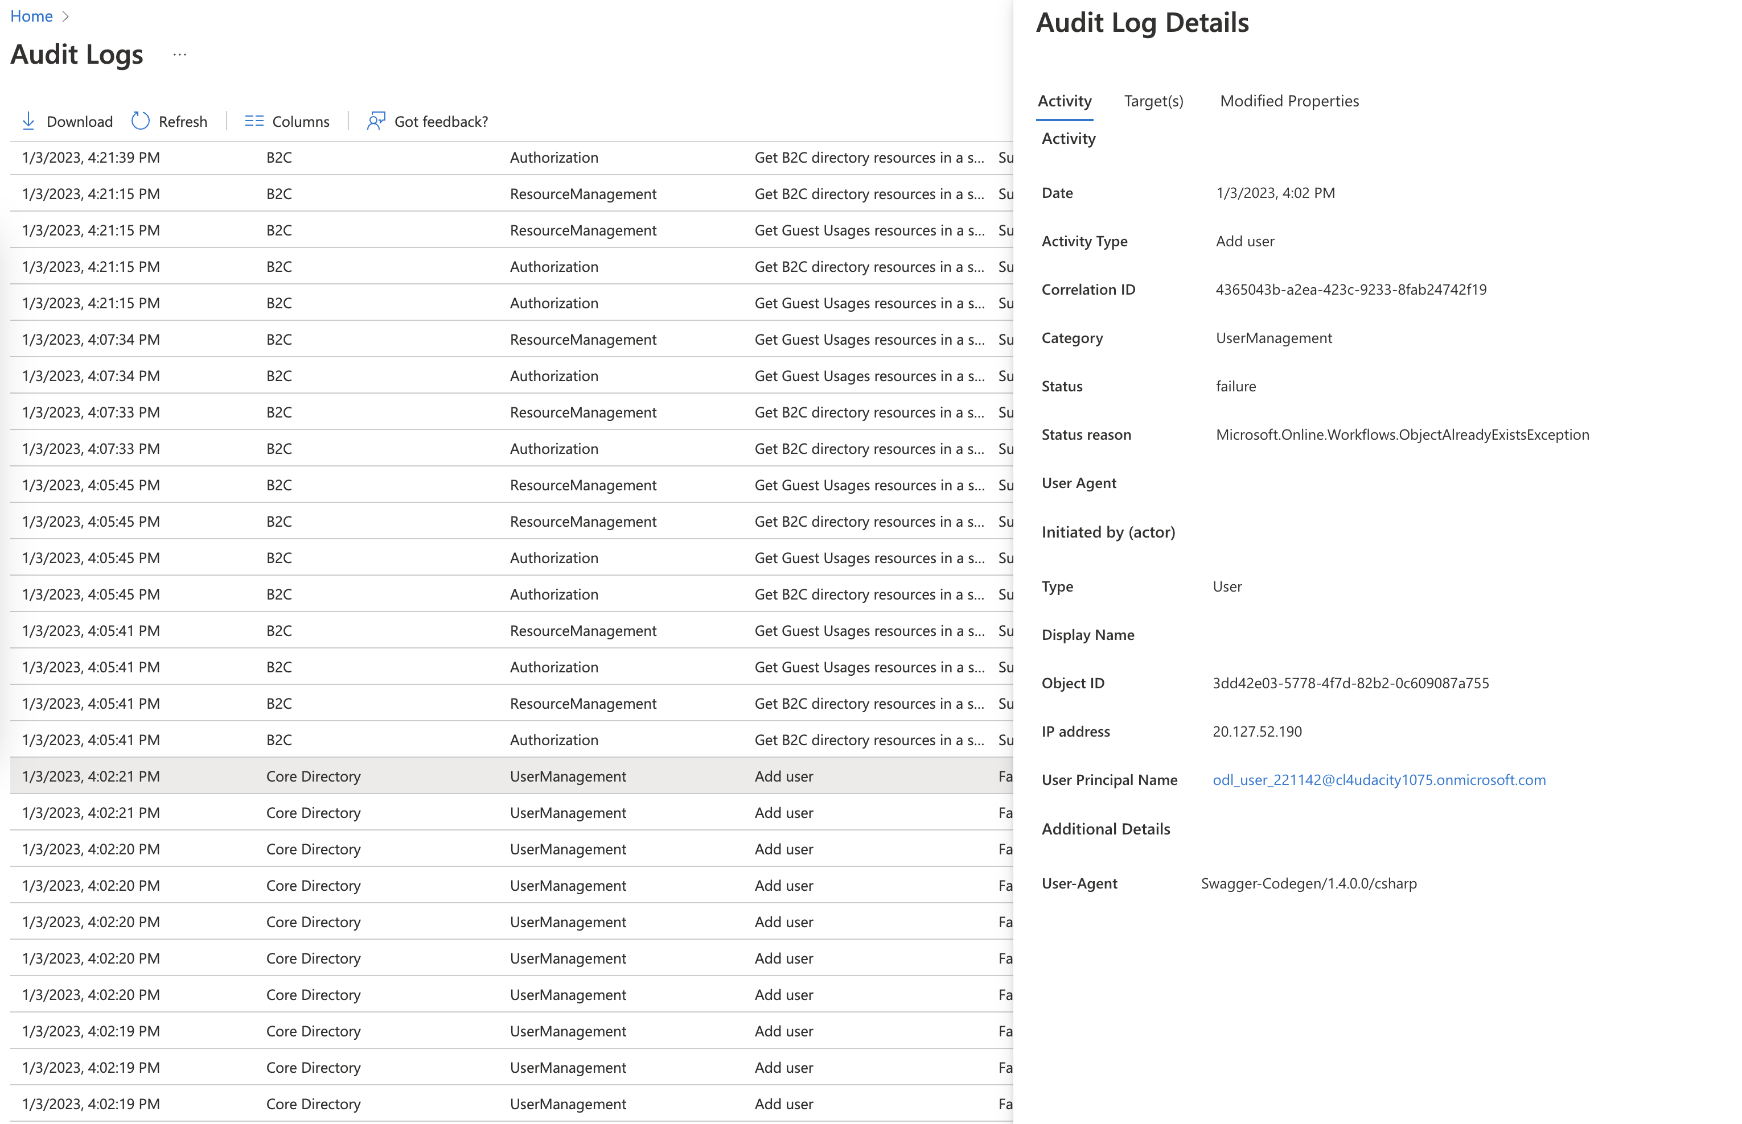

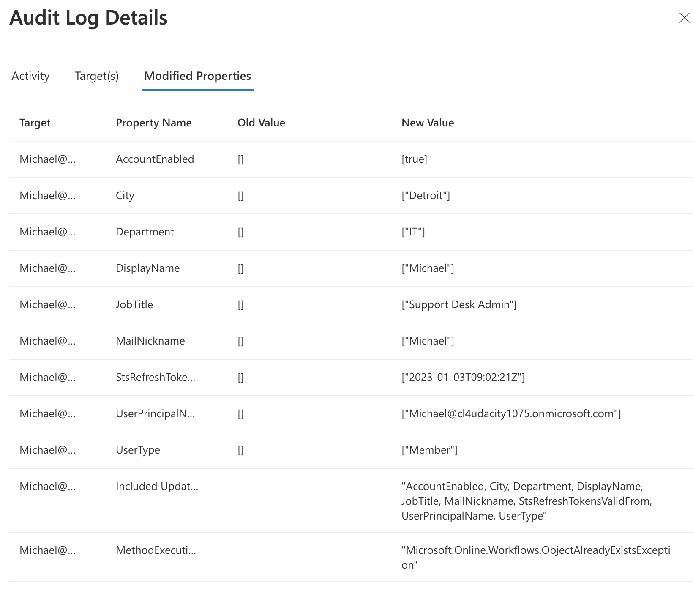

* A new user is added to the AAD, we can see the details of the action including datetime, IP address, status of the action,… The logs also shows the details of the event, in this case is the details of the user
* Audit Log 2: Add Member to Role

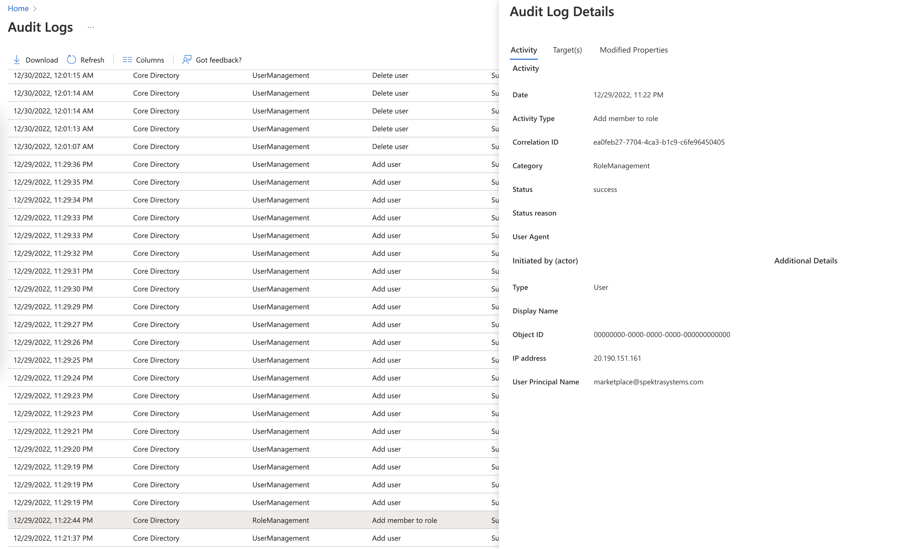

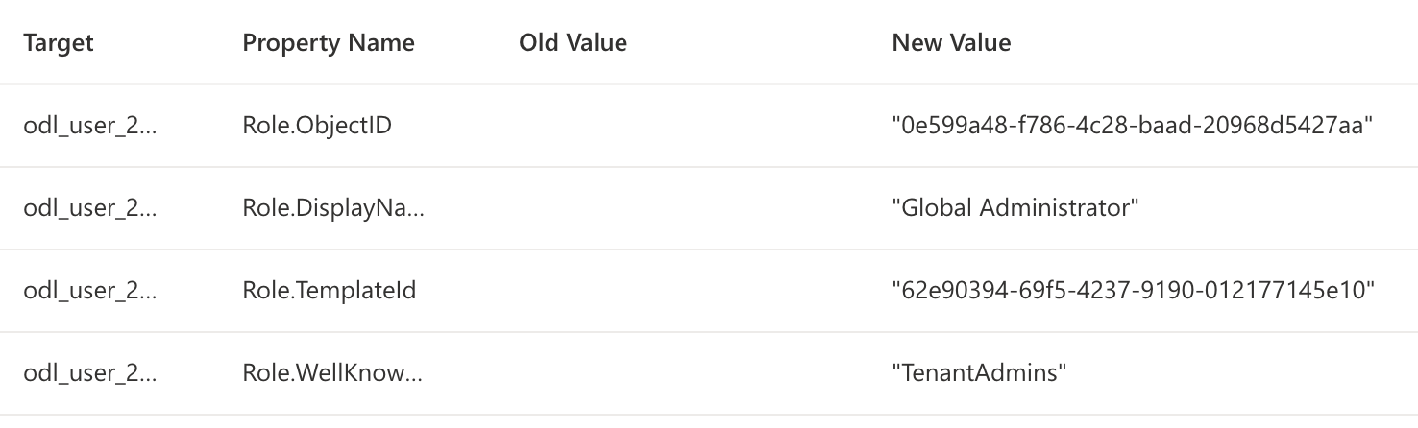

* Beside the general information, this log shows us there are 2 roles (Global Admin, Tenant Admin) assigned to user odl_user_220700
* Audit Log 2: Add Member to Role

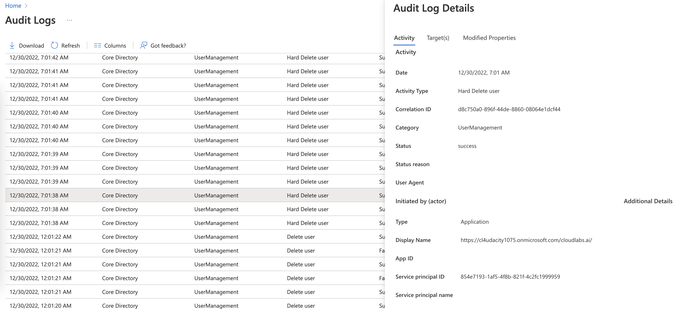

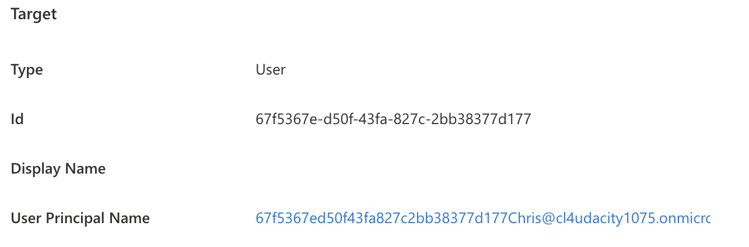

* This log shows us the the user with ID 67f5367e-d50f-43fa-827c-2bb38377d177 is hard deleted. The log contains additional info like time, action type, status of the action, category, etc.

1. Proof of Azure SQL auditing with Log analytics (devdata,proddata)

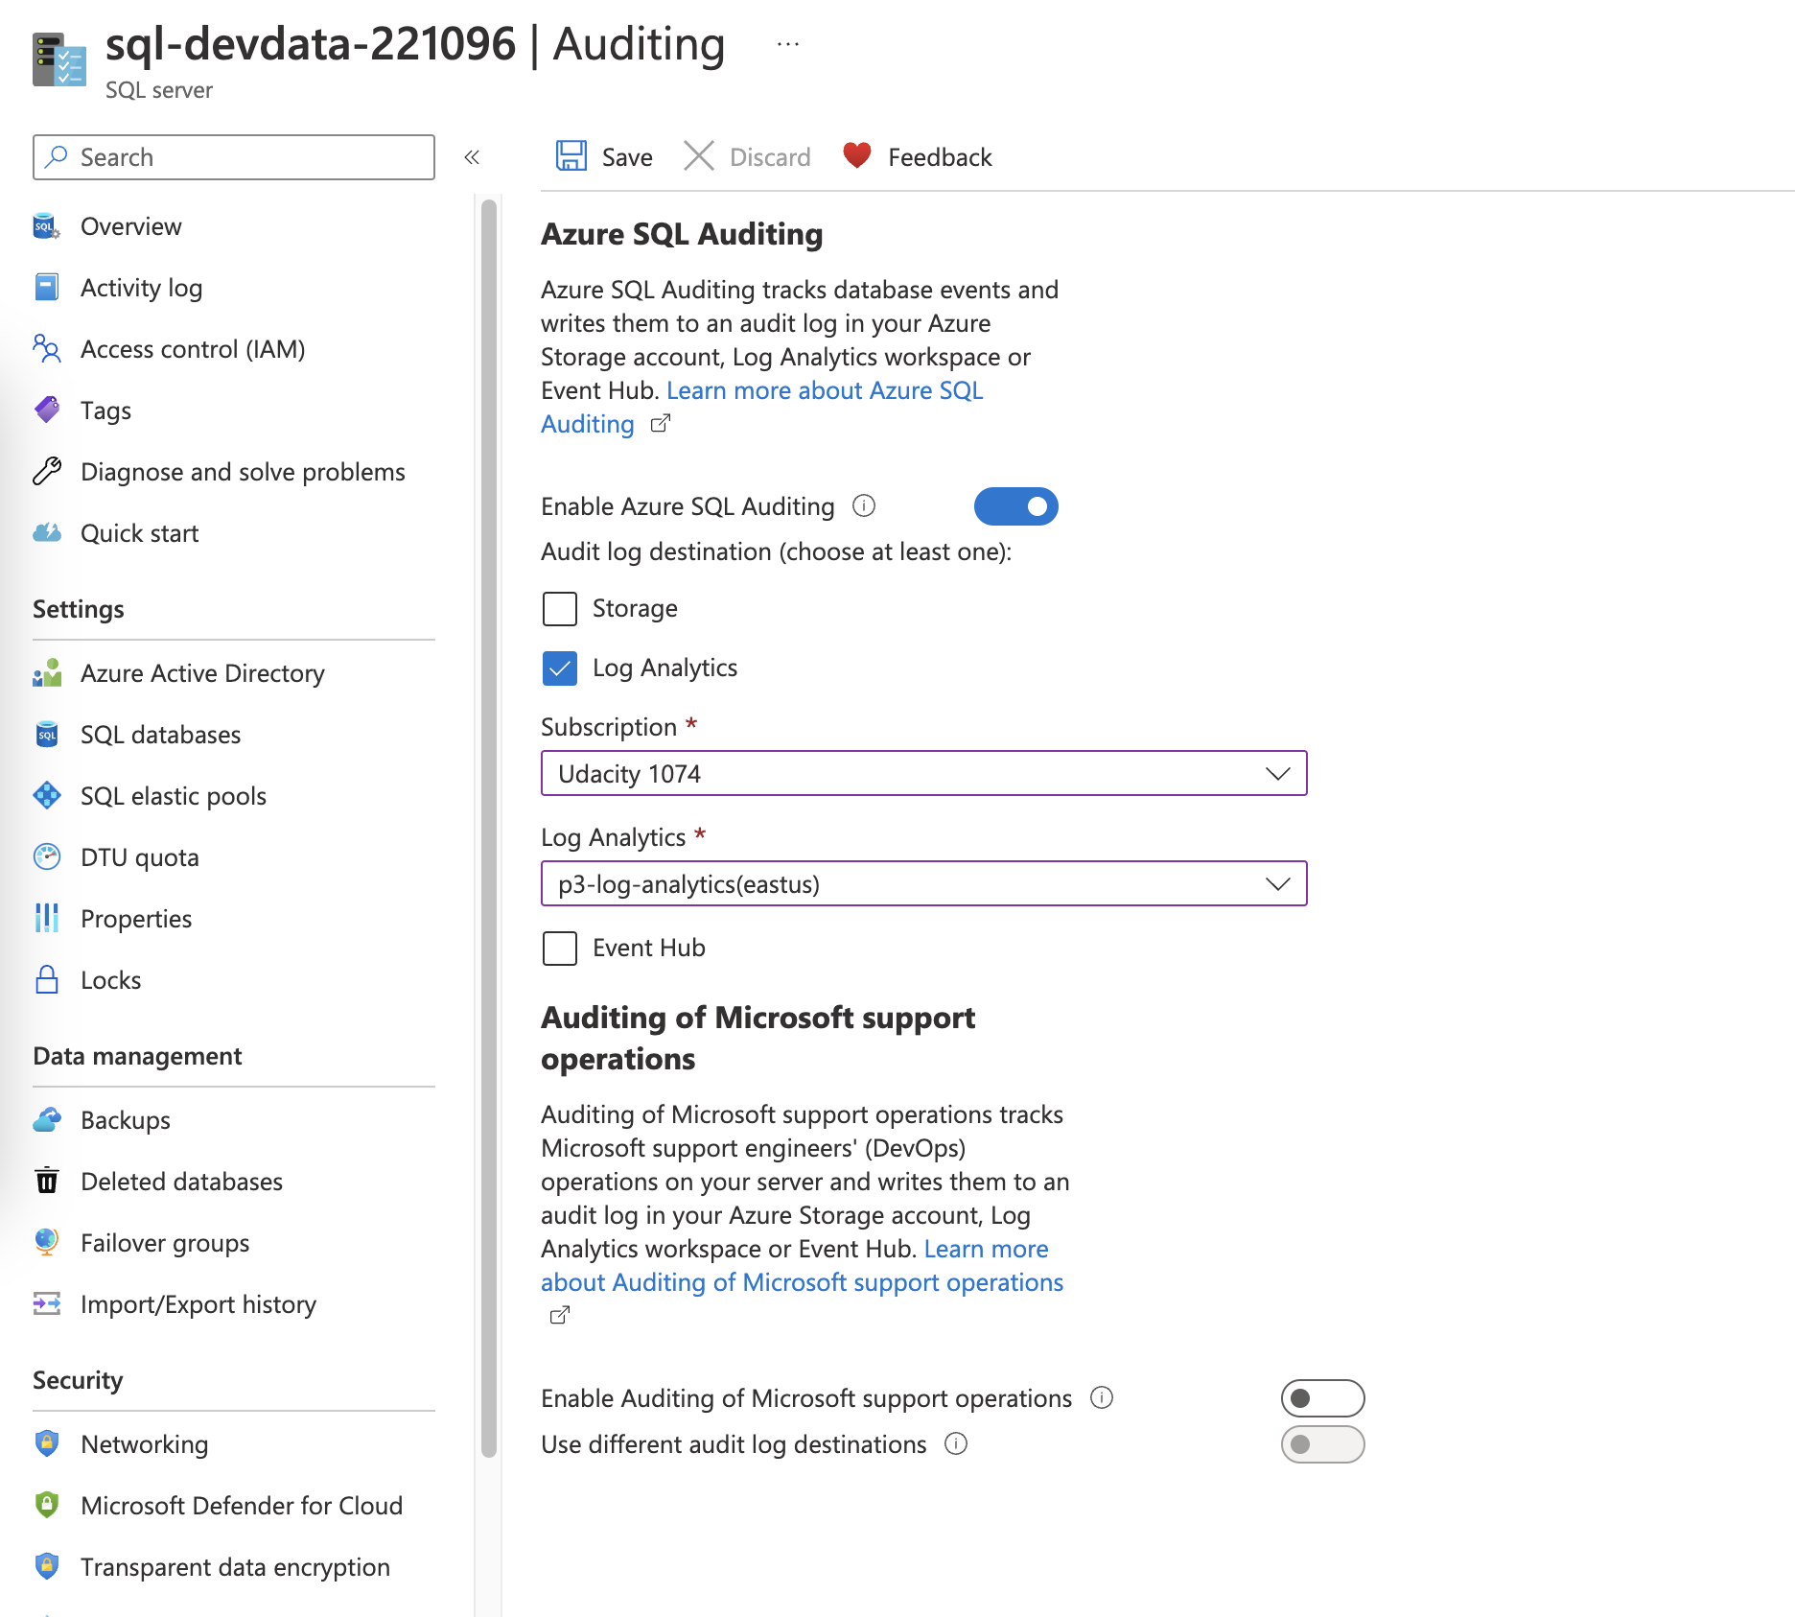

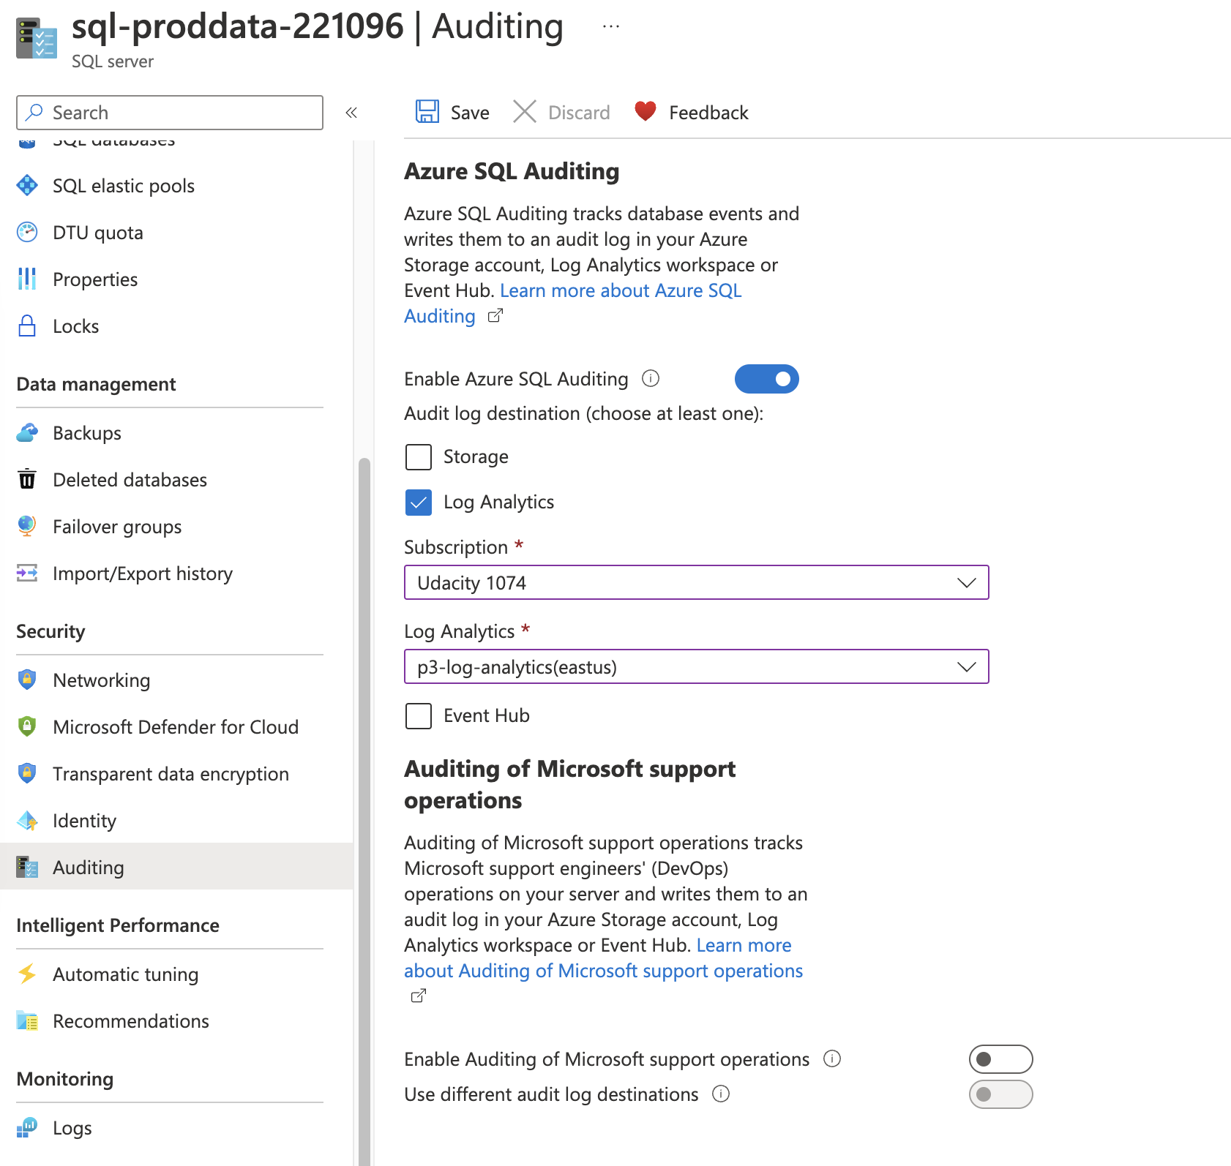

** Audit logs for SQL

*Identify 3 items from the Audit log and explain what each log shows.*

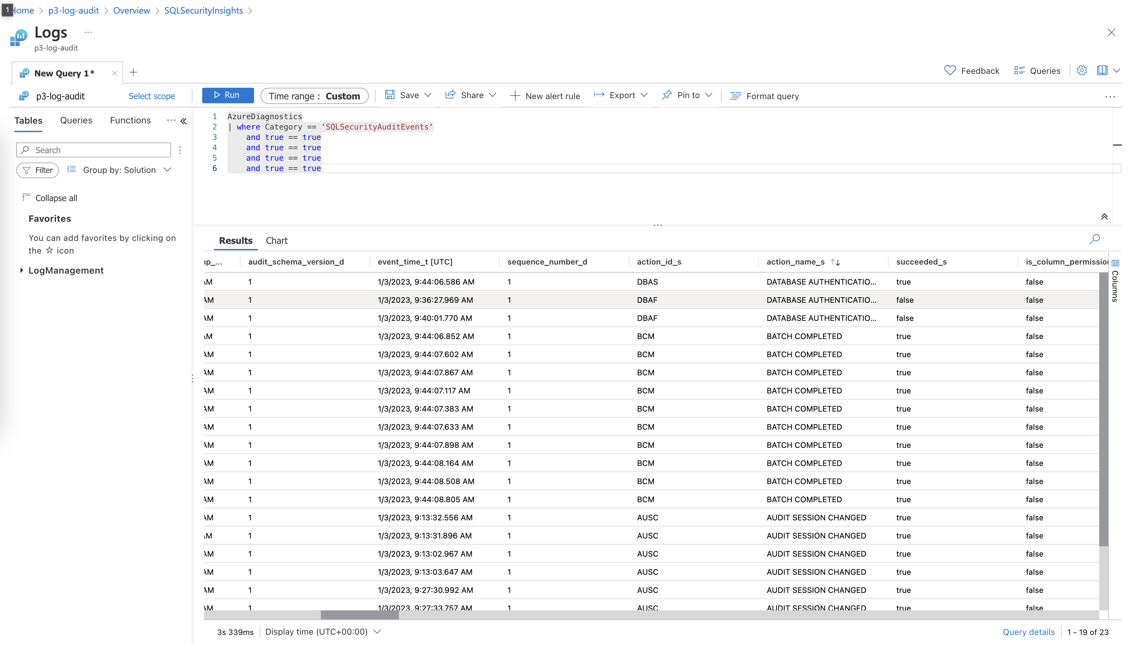

Above is the screenshot of the created log analytics workspace (configurated for 2 sql servers). There’re some logs after I tried to login and executed some queries.

The logs with action name “DATABASE_AUTHENTICATION” shows the history of attempts to login to the server with some other useful info: instance name, time, status, server principal name, etc.

The logs with action name “BATCH_COMPLETED” shows the history of the executed queries in the database, we can find the full statement, object name, database name, etc. in the logs  
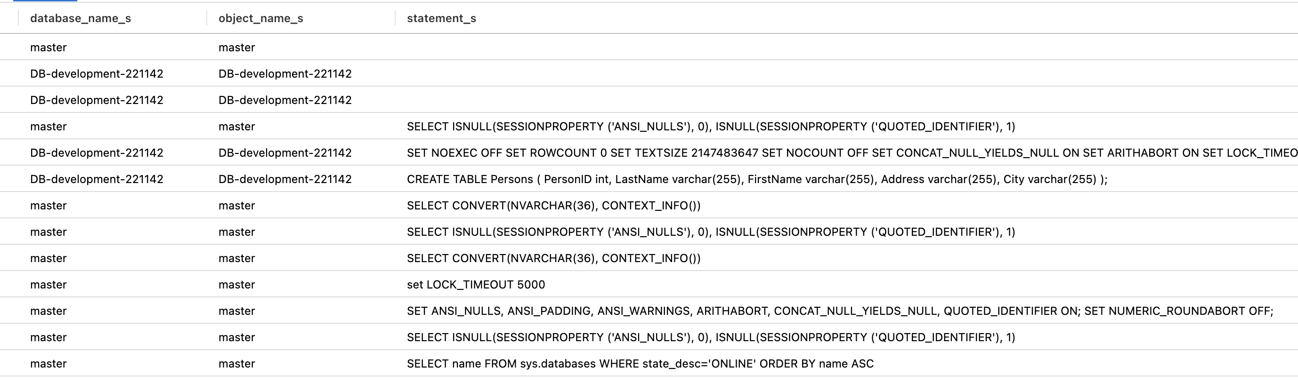

The AUDIT_SESSION_CHANGE logs are the log of log audit service in the server.

1. Proof of Sentinel connectors (2+)

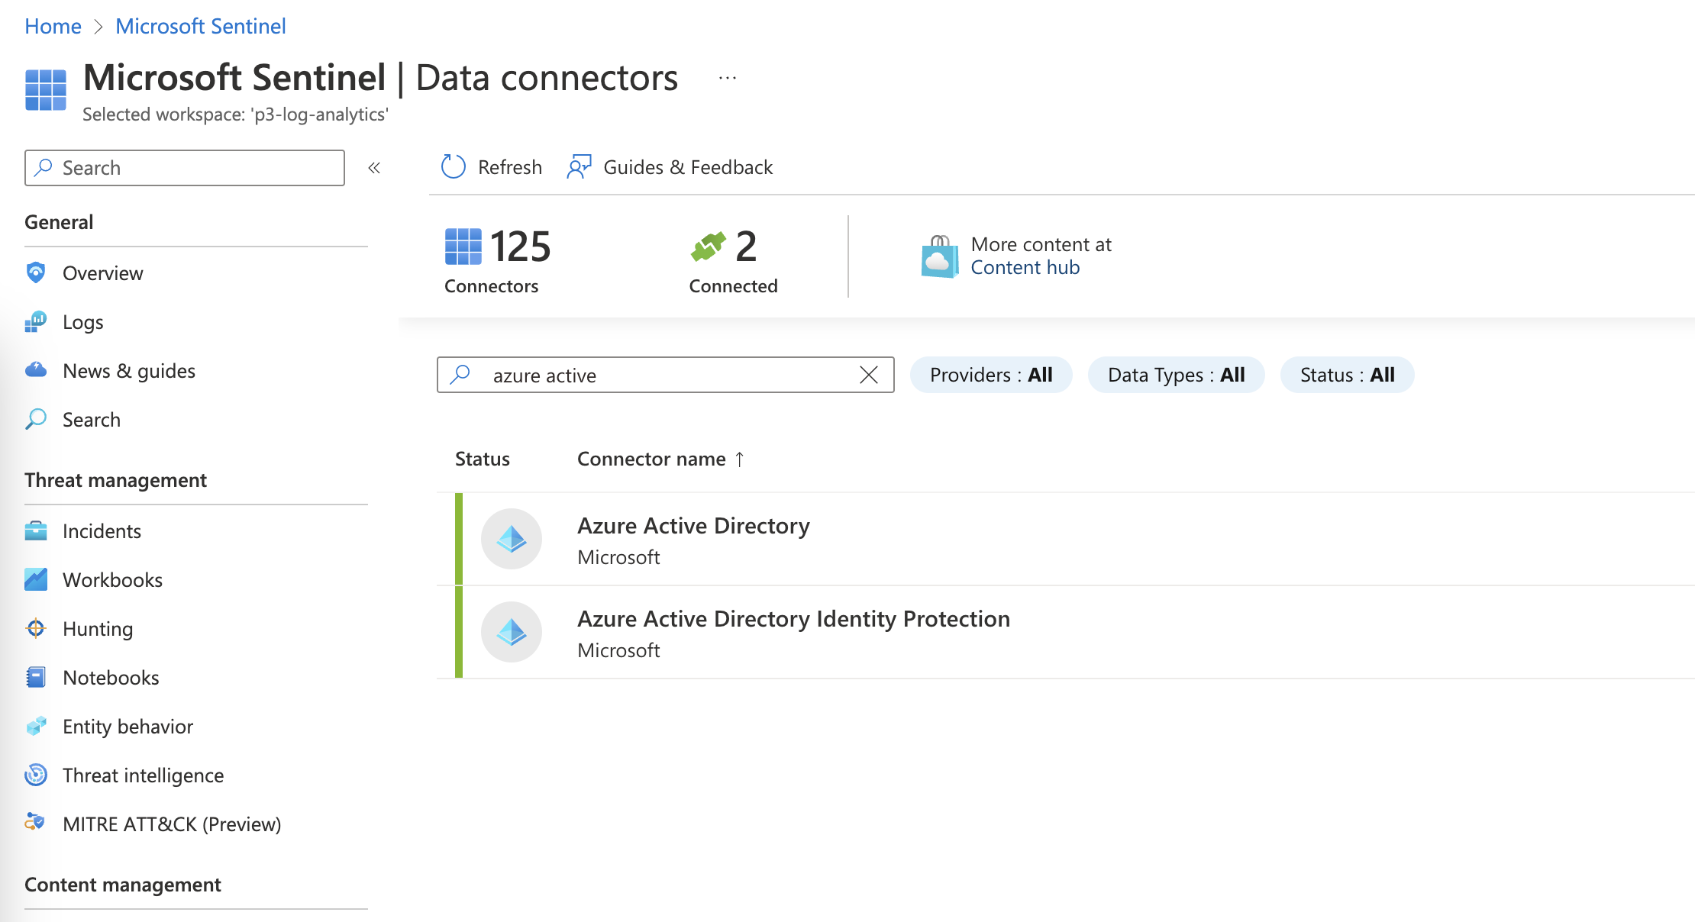

**Compliance**

1. Proof of NIST SP 800-53 rev4 policy added

